SENIOR SIX TERM 1 PHYSICS 2026

TOPIC 6/6: SOUND WAVES
Competency: The learner investigates the behaviour of sound waves and their applications in different situations.

Sound waves
Sound is a form of energy produced by vibrating objects. It travels as a longitudinal wave through a material medium.

Production
Sound is produced by vibrating objects. Vibrating objects cause nearby surrounding air molecules to vibrate. When these vibrating air molecules reach our ear, sensation of sound is produced. A sound wave is a longitudinal wave

Propagation of sound
Sound waves need a material medium for transmission so that the vibrating objects cause the nearby molecules of the medium to vibrate

Experiment to show that sound needs a material medium for the transmission
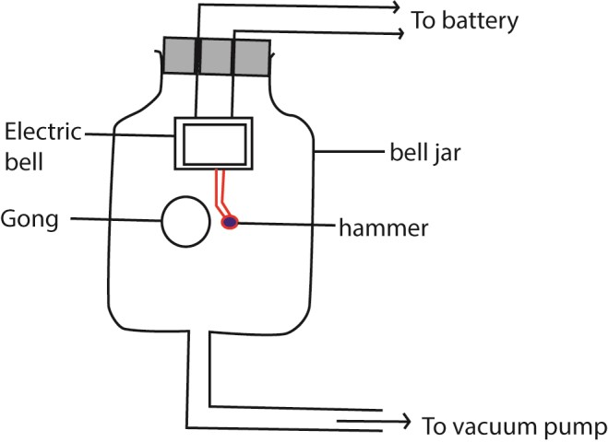

Switch on the electric bell
Switching on the electric bell, a loud sound is heard

Removal of air gradually
On gradually removing the air by a vacuum pump, the loudness of sound gradually dies away.

No sound is heard when all the air has been completely removed though the hammer is seen hitting the gong.

This shows sound waves need material medium like air, liquid or solid for transmission.

The speed of sound waves depends on:-
- Temperature.
- Density and elasticity of the medium.
- Wind in the case of air.

How each factor affects the speed of sound waves?
Density: The speed of sound waves is higher in denser medium than in less denser medium. This is the reason why the speed of sound is higher in solids than in liquids and gases because solids are generally denser.

In a steel rod for example, the speed of sound is about 5000ms⁻¹ yet in water the speed of sound is 1500ms⁻¹ because steel is denser than water.

In daily life, an approaching train can easily be detected by human ears positioned close to the rails than in air. This is explained from the fact that sound waves travel faster through solids than through air as solids are generally denser than air.

Temperature: Increasing the temperature, increases the speed of sound in air greatly because the speed of vibrating air molecules increases with temperature.

However in solids and liquids, increasing the temperature, decreases the speed of sound waves because solids and liquids become less dense as temperature increases.

Wind in the case of air: The speed of sound waves increases if the direction of sound wave travel is the same as that of the wind. If the direction of sound waves travel is opposite that of wind, the speed decreases.

Note: Pressure change in air (gases) does not affect the speed of sound wave because density of air is negligibly affected by change in pressure.

Properties of sound waves
- Reflection
- Refraction
- Diffraction
- interference

Reflection
Sound is bounced back from obstacles in similar manner to light. The reflected sound is called an echo.

Laws of reflection of sound waves state:-
i) Incident sound wave, reflected sound wave and the normal at the point of incidence all
He in the same plane, ii) The angle of incidence of sound waves is equal to angle of reflection of sound waves.

Experiment to show reflection of sound waves
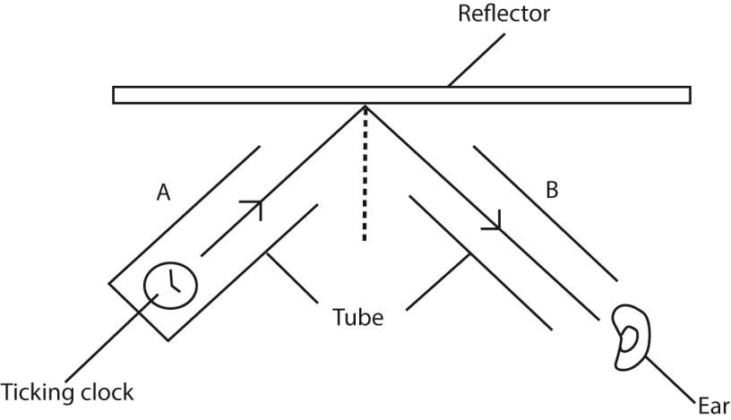

(a) Producing sound waves
Sound waves produced by the clock at the end of tube A are reflected at the hard surface reflector.

b) Moving tube B
The ear is put at the end of the tube B and the tube B is moved until the ticks of the clock are loudest. This is the direction of reflected sound wave.

Note: Hard surfaces reflect sound waves while soft surfaces absorb sound waves.

Echoes
An echo is reflected sound waves

Echoes are produced by the reflection of sound from a hard surface. Echoes are often heard in the neighborhoods of large houses, high walls, cliffs etc.

I echoes are often heard in the big churches, halls etc. They are not heard in a small room or class-room because the reflected sound waves return very quickly and mix up with the original sound wave.

Echoes are troublesome in lecture halls, cinema etc. To reduce echoes in such places, the walls are covered with soft thick porous materials.

Furniture and people in halls also reduce echoes. So many echoes are produced in empty halls compared to one filled with people because bodies of people are soft so they absorb some of the sound.

Reverberation
It is a prolongation of sound due to reflection from nearby obstacle. If the reflecting surface is nearer, the echo joins the original sound which then seems to become prolonged.

Implications of reverberations

- To some degree, reverberation is desirable in concert halls to stop the hall sounding dead so that hearing in such places is improved.
- However, too much reverberation causes confusion.

The time taken by a particular intensity of sound to die away is the reverberation time.

For echo
Velocity =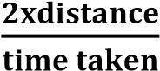

How to minimize reverberation
To minimize reverberation, add soft, sound-absorbing materials like carpets, heavy curtains, upholstered furniture, and acoustic panels to walls and ceilings, as these materials trap sound waves and reduce reflections, making a space sound drier and clearer, while diffusers can scatter waves for better sound balance. Strategically placing these elements, especially in large, hard-surfaced rooms, breaks up direct sound paths and controls echoes effectively.

Experiment to measure the speed of sound (echo method)
Two people one claps and the other records the time, while standing at a known distance from a high wall. The time taken for the sound wave to travel to and from the wall is recorded.

The exercise is repeated many times so that the average time is obtained.
Speed of sound = 2 x distance
Average time

Example 1
A man stands at a distance of 990m away from a tall building and makes a loud sound. He hears the echo after 6 seconds. Calculate the speed of sound.

For echo: Speed = 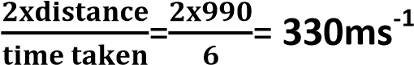

Example 25
A man stands between two walls, but nearer one of them and makes a: loud sound. If he hears the third echo after 6 seconds, calculate the distance between the two walls, (speed of sound in air is 330ms⁻¹.
V =330 ms⁻¹ d =? T = 6 seconds Velocity =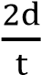
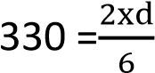
d =330x3 =990m

Example 2
A sound of frequency 150Hz is produced 45m away from a cliff. Calculate the (i). wavelength
From V =λ f
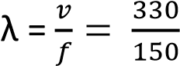= 2.3m
(ii). Time it takes the sound wave to travel to and from the cliff (Speed of sound in air=300ms⁻¹).

Time = 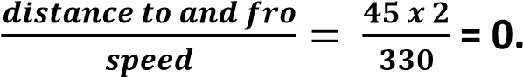 27s

Refraction of sound waves
Refraction of sound waves occurs when the speed of the wave changes as it moves from one medium to another of different density. The speed of sound waves in air is affected by the air temperature. When sound waves pass through layers of air at different temperature they are refracted i.e. turned into another direction. On a hot day sound waved are bent upwards away from the earth where they otherwise travel faster.

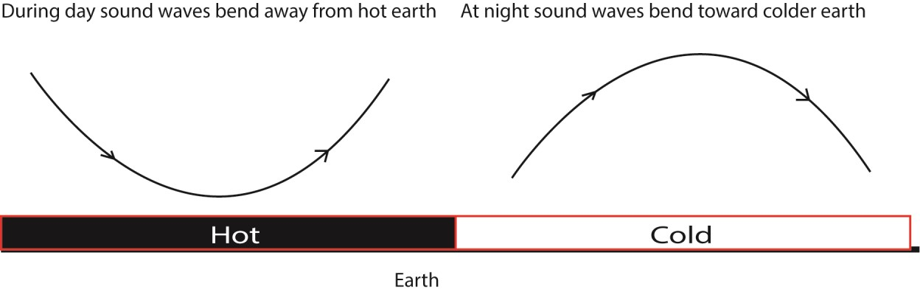

In the evening when the air near the ground becomes cool, refraction of sound is towards the earth, making it easier to hear distant sound as the range of sound is more.

Radios are clearer at night than during day because at night the sound waves are bent down towards the cool earth making the range of sound more.

Interference of sound waves

- - Constructive interference
- - Destructive interference
Overlapping sound waves produce regions of louder sound by constructive interference and regions of quiet sound by destructive interference.

If two loud speakers are connected to the same audio frequency generator, they produce sound waves of identical frequency and similar amplitude.
A louder sound is produced when the waves from the two speakers arrive in phase and interfere constructively.
A quiet sound is produced when destructive interference occurs.
If the speakers are moved closer together, the distance between the places where loud sound is heard is increased.

Experiment to show interference of longitudinal waves.
- Using two loud speaker
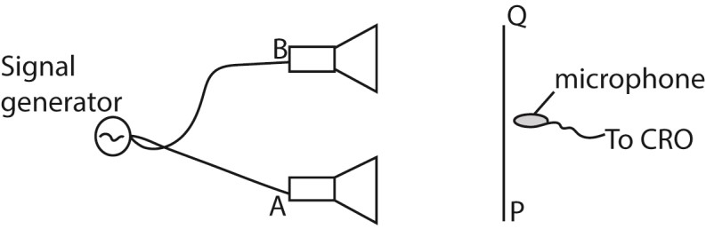
Two loud speaker A and B were connected to a signal generator. A microphone connected to the y-plates of s C.R.O with the time base switched off.
As the microphone is moved along the line PQ which is parallel to the line joining the loud speaker, the vertical trace on the screen of CRO is seen to increase to maximum and reduce to minimum at equal distances. The alternative maximum and minimum intensity are interference pattern.

- Using two tubes
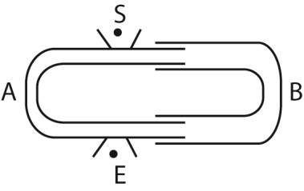
Tube A is fixed while B is free to move. A note is sounded at S and detected at E. Tube B s then pulled out slowly. It is noted that the sound detected E increases to a maximum and reduces to minimum intensity at equal intervals of the length of the tube. The alternate maximum and minimum intensity formed are interference pattern.

An experiment 1 to determine the velocity of sound in air by an interference method.
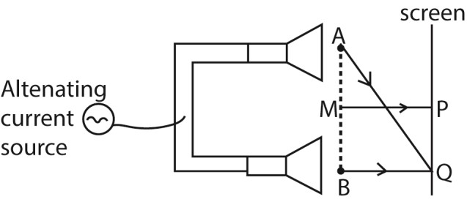
Two small loud speakers A and B about 1m apart are connected to the same oscillator so that both emit sound waves of frequency, f, in phase.

A sensitive detector is moved parallel to the line AB along PQ and it detects a maximum wave at P on perpendicular bisector MP of AB and another maximum wave when it first reaches a point Q directly opposite to B.

Constructive interference of sound wave occurs at P and Q, so the wavelength of sound wave is given by λ = AQ –BQ

The speed of sound in air is then calculated from V =fλ.

An experiment 2 to determine the velocity of sound in air by an interference method.

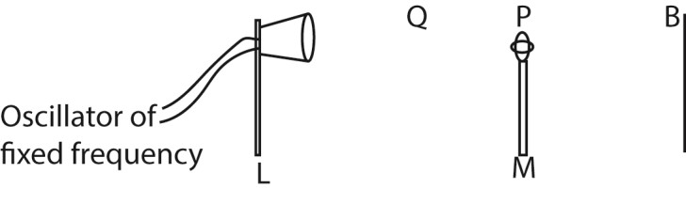
  - The loud speaker, L is connected to an oscillator of constant frequency, f.
  - A microphone, M is connected to the Y-plates of a cathode ray tube.
  - The microphone is moved away from B towards L until the amplitude of the wave on C.R.O is maximum.
  - The position P of the microphone is noted and distance BP is measured.
  - The microphone is move farther away from B to Q where another maximum amplitude of wave front is obtained. Distance BQ is measured and recorded.
  - The distance between two successive maxima d= BQ – BP = where λ is the wavelength Velocity of sound = fλ = 2df.

Ultrasonic
Sound waves with frequencies above 20 kHz are called ultrasonic waves. They are emitted by bats. Sound of high frequency that human ear cannot detect is described as ultrasonic.

Applications of ultrasonics
- Ultrasonic enable bats to judge the distance of an object from the time taken by the reflected wave to return.
- Ultrasonic are used in spectacles for blind to judge distances of an object from the time taken by reflected waves to return. Such spectacles contain ultrasonic sender and receiver.
- In sonar (echo-sounding system) of ships use ultrasonic wave to measure the depth of sea and to detect shoals of fish.
- In industry, ultrasonic waves are used to reveal flaws in welded joints and also holes are cut in glass and steel by ultrasonic drills.
Note:
In an echo sounder (sonar, ultrasonic waves are used because they:-
i) Cannot be confused with engine sound and other sound made ship,
(ii) Can penetrate sea water to a large distance without undue loss of energy. ii) They are not much detracted.

Frequency and audio frequency range.
The human ear has a range of sound frequencies which it can hear. The lowest limit of audibility is about 30Hz and the upper limit audibility for most people is between 20 kHz and 30 kHz.

In daily life, a dog is more able than a human being to detect the presence of a thief tiptoeing at night. A thief tiptoeing at night produces sound of low frequency that can only be detected by dog ears not human being ears because the dog has wider ears than human being ears.

The Doppler Effect
It is the apparent change in frequency of a wave motion due to relative motion between the source and observer.
Calculation of Apparent Frequency based Doppler Effect
Suppose V is the velocity of sound in air, u_{s} is the velocity of the source of sound S, u₀ is the velocity of an observer 0, and f is the true frequency of the source.
- Source moving towards stationary observer.
  - If the source S were stationary, the f waves sent out in one second towards the observer
O would occupy a distance V, and the wavelength would be V/f

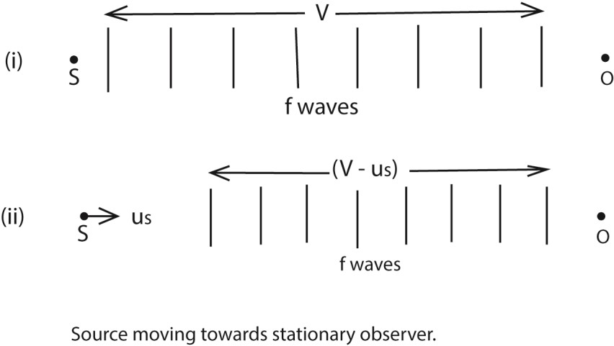
  - If S moves with a velocity u_{s} towards 0, however, the f waves sent out occupy a distance (V – u_{s}), because S has moved a distance u_{s} towards 0 in 1s, fig. (ii).
Thus the wavelength λ' of the waves reaching O is now 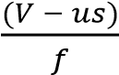
But velocity of sound = V
Apparent frequency, f’ = 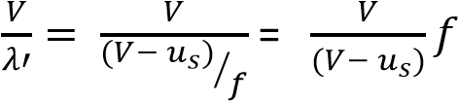
Since (V - u_{s}) is less than V, f' is greater than f; the apparent frequency thus appears to increase when a source is moving towards an observer.
- Source moving away from stationary observer.
In this case the f waves sent out towards 0 in 1s occupy a distance (V + u_{s}),

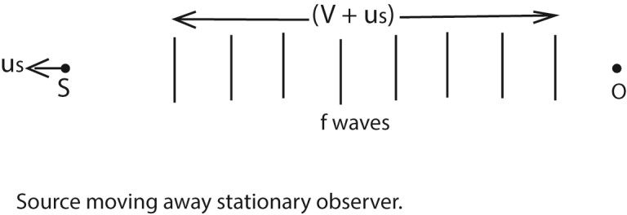
Thus the wavelength λ' of the waves reaching O is now 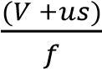
But velocity of sound = V
Apparent frequency, f’ = 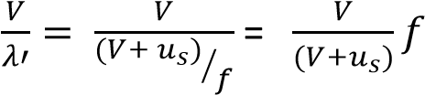
Since (V + u_{s}) is greater than V, f' is less than f; the apparent frequency thus appears to reduce when a source is moving towards an observer.

- Source stationary, and observer moving towards it.
Since the source is stationary, the f waves sent out by S towards the moving observer O occupies a distance V,

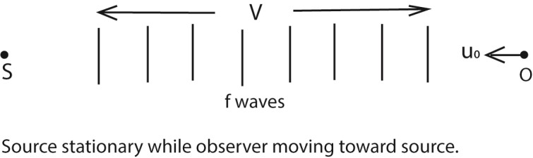

The wavelength of the waves reaching O is hence V/f, and thus unlike the cases already considered, the wavelength is unaltered.
The velocity of the sound waves relative to O is not V, however, as O is moving relative to the source.
The velocity of the sound waves relative to O is given by (V + u_{o}) in this case, and Hence the apparent frequency f' is given by
Apparent frequency, f’ = 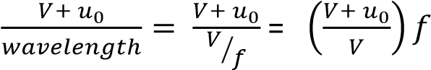
Since (V + u₀) is greater than V, f' is greater than f; the apparent frequency thus appears to increase when an observer is moving towards the source.

(d) Source stationary, and observer moving away from it.
Since the source is stationary, the f waves sent out by S towards the moving observer O occupies a distance V,
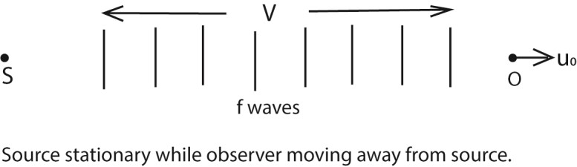

The wavelength of the waves reaching O is hence V/f, and thus unlike the cases already considered, the wavelength is unaltered.
The velocity of the sound waves relative to O is not V, however, as O is moving relative to the source.
The velocity of the sound waves relative to O is given by (V - u_{o}) in this case, and Hence the apparent frequency f' is given by
Apparent frequency, f’ = 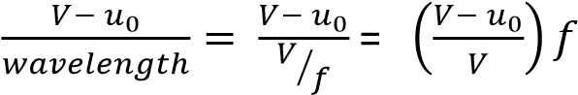
Since (V - u₀) is less than V, f' is less than f; the apparent frequency thus appears to reduce when an observer is moving away from the source.

Source and Observer Both Moving
If the source and the observer are both moving, the apparent frequency f' can be found from the formula f’ = 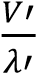
where V' is the velocity of the sound waves relative to the observer, and λ’ is the wavelength of
the waves reaching the observer. This formula can also be used to find the apparent frequency in any of the cases considered before.
- Suppose that the observer has a velocity, u_{o}, the source a velocity u_{s}, and that both are moving in the same direction. Then
V' = V- u_{o} And
λ' = (V - u_{s})/f
f’ = 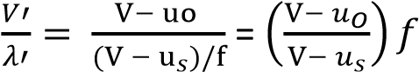

Suppose that the observer has a velocity, u_{o}, the source a velocity u_{s}, and If the observer is moving towards the source, then
V' = V+ u_{o}
And
λ' = (V - u_{s})/f
f’ = 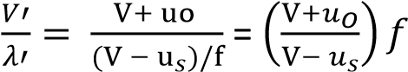
- A source of sound moving with velocity, u_{s}. approaches an observer moving with velocity u₀ in the same direction. Derive the expression for frequency of sound heard by observer. (05marks)
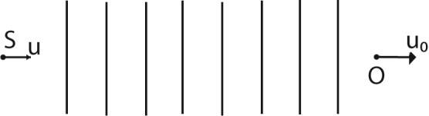

Let c be the velocity of sound from a source of frequency, f.
Apparent wave length, 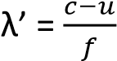
Apparent velocity c’= c-u₀
Apparent frequency = 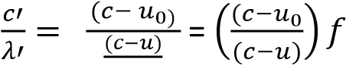

Example 3
One species of bats locates obstacles by emitting high frequency sound waves and detecting the reflected waves. A bat flying at a steady speed of 5ms⁻¹ emits sound of frequency 78.0 kHz and is reflected back to it.
- Derive the equation for the frequency of the sound waves reaching the bat after reflection
(05marks)
Suppose the velocity of sound wave is c and that of the bat is v₀ and the frequency is f. The velocity v’ of reflected sound relative to the bat is given by v’ = v₀ + c.
The apparent wave length 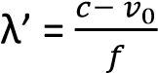
But the apparent frequency, f’ = 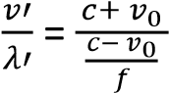
Hence f’ = 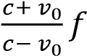
- Calculate the frequency of sound received by the bat given the speed of sound in air is 340ms⁻¹.
(02 marks)
From, f’ = 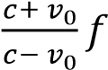
f' = 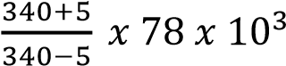 = 90.3kHz

Example 4
A motor cyclist and police car are approaching each other. The motor cyclist is moving at 10ms-1 and the police car at 20ms-1. If the police siren is sounded at 480Hz. Calculate the frequency of the note
heard by the cyclist after the police car passes by. 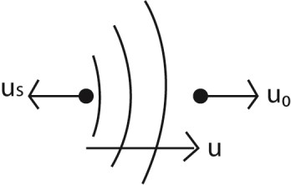
Apparent wavelength reaching the observer, 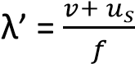
Apparent velocity of sound received, v’ = v – u₀
Apparent frequency of sound received, f’ = 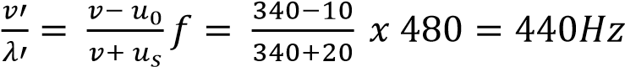

Example 5

- A source of sound moving with velocity, u. approaches an observer moving with velocity u₀ in the same direction. Derive the expression for frequency of sound heard by observer. (05marks)

Let c be the velocity of sound from a source of frequency, f.
Apparent wave length, 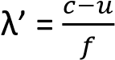
Apparent velocity c’= c-u₀
Apparent frequency = 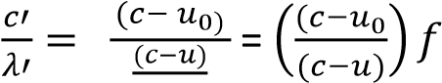

- Two whistles are sounded simultaneously. The wavelengths of the sounds emitted are 5.5m and
6.0m respectively. Find the beat frequency if the speed of sound is 330ms⁻¹.
For 1st sound 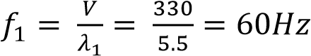
For 2nd ^{t} sound 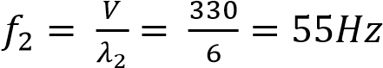
Beat frequency

TOPIC 2/5: MAGNETISM IN MATTER
Competency: The learner appreciates the magnetic properties of matter and uses them to model different useful magneto-electric devices.

Magnet
A magnet is a piece of metal which is able to attract another magnet or a magnetic material.

Lodestone is a naturally occurring magnet.

A magnet exerts magnetic forces on magnetic materials. The magnetic forces are:
- Forces of attraction.
- Forces of repulsion.

Uses of magnets
- In construction of cycle dynamos, telephones, loud speaker, electric meters, current measuring instruments.
- To remove metal splinters from oil engine
- For door closures
- Electric bell
- Magnetic ink
- Computer memory cards.
- Electric motor
- Magnets are used in hospitals to remove iron pieces from the eye of patient.
- Making magnetic tapes used in audio and video recorders.

Properties of a magnets
- It attracts other pieces of metals.
  - Materials attracted by magnets are called magnetic materials
  - Materials strongly attracted by magnets are called ferromagnetic materials such as iron, nickel steel, cobalt.
  - Materials that are not attracted by magnets are non magnetic materials, e.g.
copper, brass, aluminium, wood and plastics

- It possesses magnetic poles- theNorth Pole and South Pole at the ends of a magnet. These are places where magnetic forces appear to be concentrated.

(iii) A freely suspended magnet rests in the North-south direction
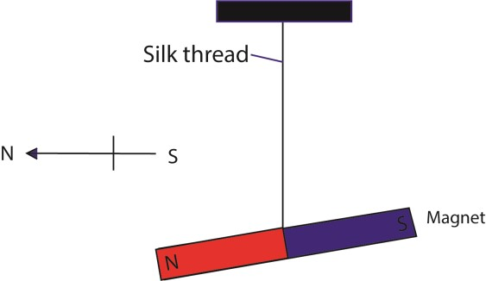

Explanation; This is because the earth is a magnet having its south pole in the northern hemisphere and its north pole in the southern hemisphere so there is attraction between the poles of freely suspended magnet and the earth’s magnet.

Law of magnetism
States that like poles of magnets repel and unlike poles of magnet attract

Testing for polarity of a pole
A known pole of magnet is brought near the ends of a material suspected to be a magnet. If repulsion occurs then that end of material is a like pole. The poles of a given magnet or magnetized material are tested by repulsion occurring between poles of a known magnet and that of the material whose polarity is to be tested.

NB: Repulsion is a sure test for polarity because repulsion only occurs due to like poles of magnets. While attraction is not a sure test because attraction can either result from unlike poles of magnets or from magnet and Ferromagnetic material which is not magnetized.

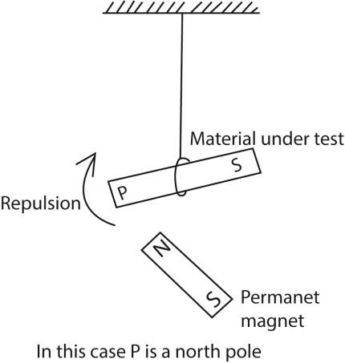

Magnetic field
This is a region of space around a magnet or a moving electric charge within which a force of magnetism acts.
In a magnetic field:
- A magnetic force can be experienced
- A moving charge experiences a magnetic force - A current- currying conductor experiences a force - An e.m.f is induced in a moving conductor.

The figure below shows Iron filings attracted to a bar magnet to show the magnetic field.
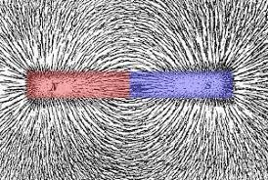

Magnetic Flux
- All magnets, no matter what their shape, have two regions called magnetic poles; North and South.
- The north of a compass magnet is the end that points towards the Earth’s north.
- Like poles repel, unlike poles attract
- Magnetic fields are lines of force draw from the North to the South of a magnet. The closer the Field lines the stronger the magnetic fields.
- The direction of magnetic field B, at any location is given by the direction of North Pole of the compass needle
- Magnetic field B is measured in N/Am or Tesla, T
Drawings of magnetic field patterns are shown below

(a) For a an isolated bar or horse Shoe magnet

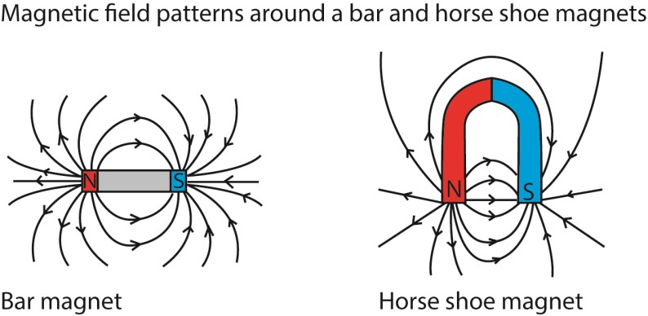

- Lines of force leave the North-Pole and enter the South Pole.
- An arrow should be drawn to show the direction of field lines
- Lines of force do not cross each other
- Magnetic field is strongest at the poles

(b) In two nearby magnets,
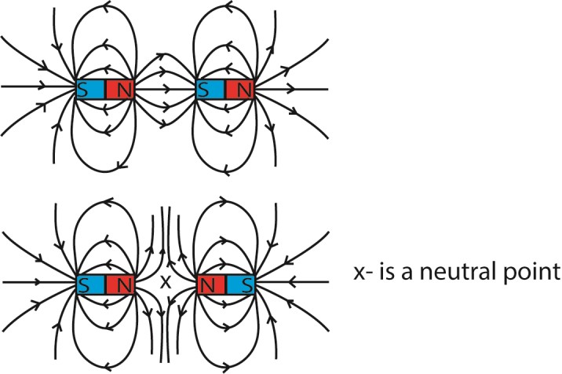
Note that a line of the field will pass in opposite directions if like poles are nearby. A neutral point will be between them

(c) Earth’s magnetic field
The earth’s magnetic field lines are made up of parallel lines running from geographical south to geographical north.
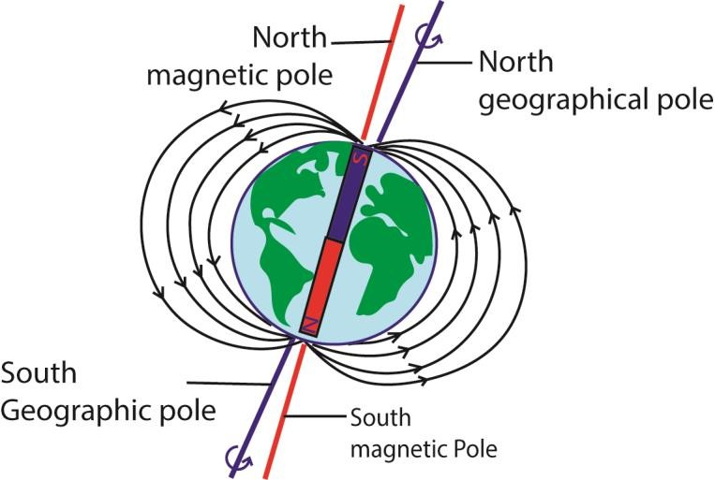
The study of the earth’s magnetic field involves:
(i) Two marginal lines called magnetic meridian and geographical meridian (ii) Two angles called angles of dip and angle declination

Definitions
Magnetic meridian: This is the vertical plane containing the magnetic axis
Geographic meridian: this is the vertical plane passing through the axis of rotation of the earth.
Magnetic axis: This is the imaginary line passing through the earth’s magnetic North and South Pole.
Geographical axis: This is the imaginary line through the center of the earth and passing through the geographic North and south.

Angle of dip (inclination) α: Angle of dip is the angle that the axis of a freely suspended bar magnet makes with the horizontal when the magnet settles
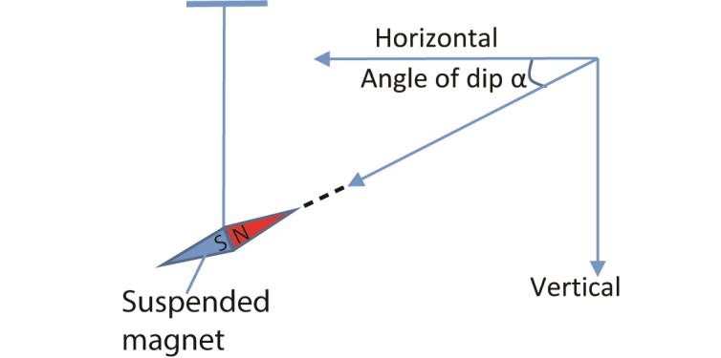
Generally the angle of dip varies from 0⁰ at the equator to 90⁰at the North Pole.
Magnetic Equator: This is the greatest circle in a horizontal plane perpendicular to the magnetic meridian where a freely suspended bar magnet experiences zero magnetic dip.

Explanation
At the magnetic equator, the earth’s magnetic field lines are parallel to the horizontal. Therefore the angle of dip at the equator is zero, (α =0)
As one moves along a given longitude towards the North Pole, the resultant magnetic field lines meet the earth’s surface at angles greater than 0⁰ but less than 90⁰ thus the angle of dip at such a position is also greater than zero but less than 90⁰. i.e. 0⁰ < α <90⁰.
At the North Pole, the magnetic field lines are normal to the earth’s surface, thus they are perpendicular to the horizontal. Therefore the angle of dip at the North Pole = 90⁰ or α = 90⁰.

Angle of declination (magnetic variance)
This is the angle between the earth’s magnetic and geographical meridians. Or the angle between magnetic north and true north.

(d) Magnetic field patterns due to current carrying conductors
When a straight wire or conductor is carrying a steady or direct current, a magnetic fields is created or generated around it. For a straight conductor, the magnetic field pattern is uniform concentric circles around it.
The direction of magnetic field is determined by Right hand grip rule

Right hand grip rule
Imagine gripping the conductor with the thumb straight in the direction of flow of current, with the finger curled around it, the direction in which the fingers gives the direction of magnetic field around the conductor.
Magnetic pattern due to

(i) A straight (conductor carrying current I) - (Current from left to right)
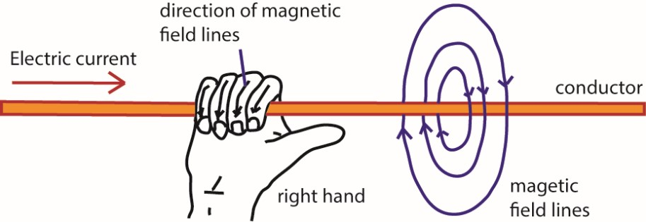

- Current from right to left
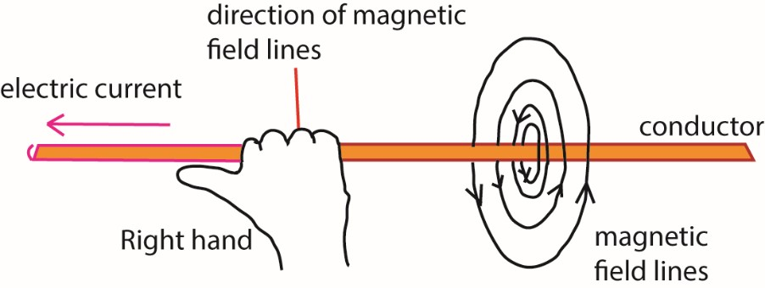

- A straight wire carrying a current perpendicularly out of or into the plane of paper as shown in fig (a) and (b) respectively below
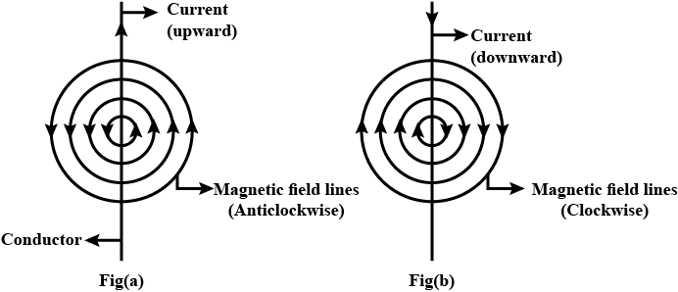
- Magnetic field pattern due to two current carrying conductors having current flowing in same and opposite direction
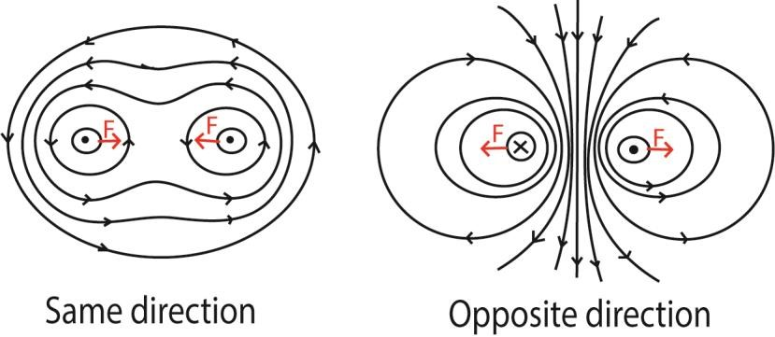

(e) Magnetic field pattern due solenoid carrying a current
Solenoid consists of a length of insulated wire coiled into a cylinder shape.
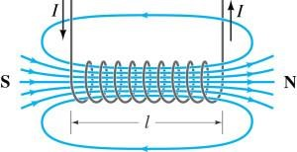
- Current in solenoid produces a stronger magnetic field inside the solenoid than outside. The field lines in this region are parallel and closely spaced showing the field is highly uniform in strength and direction.
- Field lines outside the solenoid are similar to that of a bar magnet and it behaves in a similar way – as if it had a north pole at one end and South Pole at the other end.
- Strength of the field diminishes with distance from the solenoid.
- Strength of the magnetic field can be increased by:
  - increasing the current in the coil
  - increasing the number of coils in the solenoid; and (iii) using a soft iron core within the solenoid.
- Reversing the direction of the current reverses the direction of the magnetic field.

- Right-hand rule can be used to find the direction of the magnetic field. In this case, point the wrapped fingers (along the coil) in the direction of the conventional current. Then, the thumb will point to the direction of magnetic field within the solenoid.
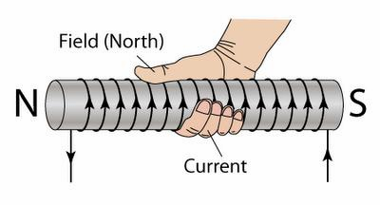
Example 1
The diagram shows a piece of soft iron bar suspended freely on a spring balance. One end of the bar is close to the end of the coil connected to a source of e.m.f via switch K.

K

A

B

Spring balance

Iron bar

coil

When switch K is closed, the spring balance reads 50B. State the polarity of AB and explain your observation

Solution
The upper end of the coil is a North Pole when K is closed.
Increase in spring balance reading shows that the iron bar is attracted. Thus A is a south pole while B is the North Pole because from right hand rule, the north pole of the coil is the top end.

(f) Magnetic field due to a bar magnet placed in the earth’s local magnetic field
- North Pole of the magnet facing down (geographical south)
- North of the magnet facing Up (geographical North)

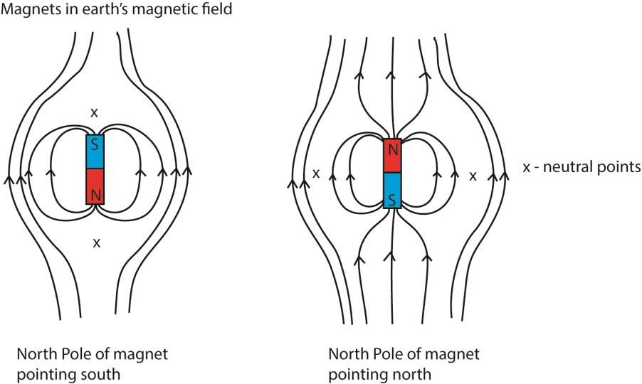

(g) A straight wire carrying a current perpendicular (across) the earth’s local magnetic field

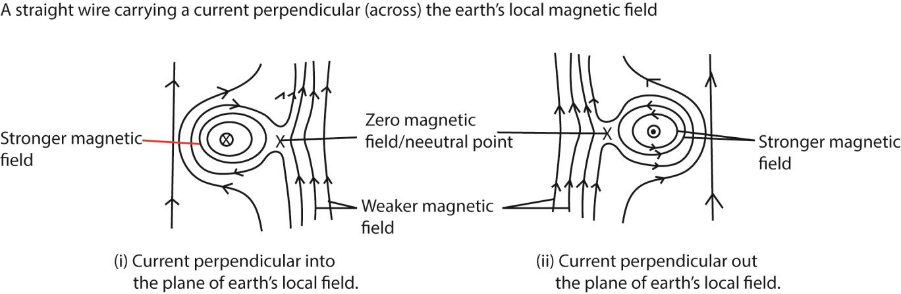

Neutral point
This is a region of space where two magnetic fields of equal magnitude and opposite direction cancel out. A magnetic dipole (compass needle) experiences zero magnetic force at this point.
Magnetic flux and magnetic flux density B, deduce its expression

Magnetic domain theory
A magnet is made us of tiny molecular magnets called dipole arranged in groups called magnetic domains, lined up with their N-poles pointing in the same direction.

In nonmagnetic materials, the domains are randomly mixed and their magnetic effect cancels each out.

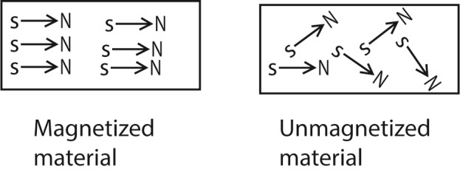

Magnetization
This is a process by which randomly arranged molecular magnet of a ferromagnetic material are arranged to point in one direction.

Methods of magnetization
These include:
- Single touch method.
- Double touch method.
- Electrical method using direct current (d.c.).

Single touch or single stroke method
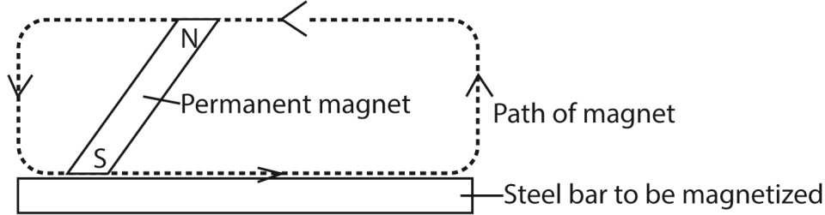

Single stoking
A steel bar (Ferromagnetic material) is stroked several times from end to end using a bar magnet. The stroking is done in the same direction and using the same pole of bar magnet.

Molecular magnets explanation
The stroking of the magnet pulls the randomly molecular magnets to face in one direction thus material becomes magnetic.

Disadvantage of single stroke method
The magnet produced has one pole nearer to the end as compared to the other pole

Identification of a pole
The pole of the bar magnet being used for stroking should be the same pole induced at the end of the steel bar from where stroking starts.

Double touch method or double stroke method
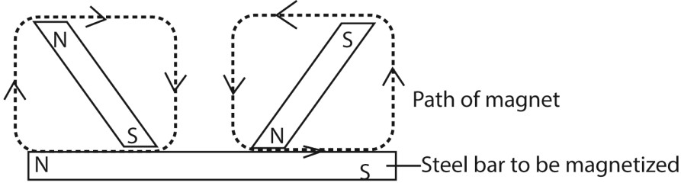

This uses two bar magnets placed at the centre of the steel bar with unlike poles as in the diagram. The stroking begins in the middle of the steel bar and ends at the opposite ends. The magnets are raised high at the end of each stroke before another one begins. This prevents reversing the acquired magnetism.

Molecular magnet
As stroking is done, the molecular magnets are pulled to face in one direction therefore creating poles at the ends of the steel bar.

Advantage of a double touch method over a single touch method
All poles are at both ends while for single touch method one pole is nearer to end than the other.
Disadvantages of double touch method over a single touch method Double touch method is more expensive and tiresome.

Electrical method
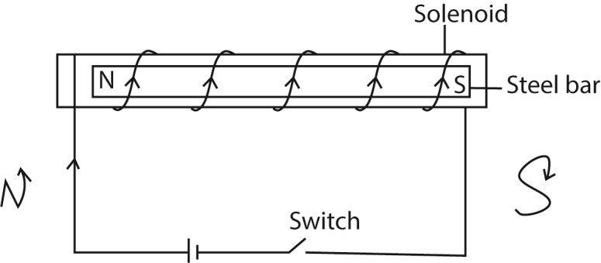

The steel bar to be magnetized is placed inside a solenoid connected to the cells. When direct current is switched on for some time, the bar will be magnetized

Note that with a.c. current the bar is not magnetized

Polarity of steel bar
The polarity of the steel bar depends on the direction in which the current is flowing. Current flows from positive to negative, so if on looking at the end of solenoid, current is flowing in a clock wise direction, that end will be South Pole but if it is flowing anti clockwise the end will be a north pole.

Induction method
When a magnetic material is kept close to a magnet for long time it gets magnetized.

Magnetic saturation
This is the maximum level of magnetization when the resultant magnetic axes of all domains in magnetic material are aligned with the magnetizing field.

Demagnetization
Demagnetization is the process through which magnets lose their magnetism Demagnetization result in scattering molecular magnets to face in randomly.

Methods of demagnetization (i) By Heating:
Heating a magnetized material makes it loses its magnetism. This is because the temperature rise causes the vibrations of molecular magnets to become so great that their ordinary arrangement is destroyed.

(ii) By hammering:
Hammering a magnetized material placed in east-west direction, makes it loses most of its magnetism. This is because when a magnet is hammered, the vibrations of the molecular magnets increase which result in random arrangement.

(iii) By electrical method using alternating current

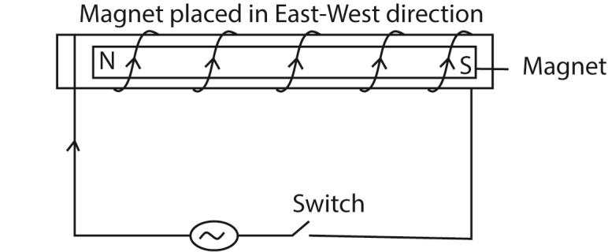
Here an alternating current is supplied to the solenoid in which the magnet is placed in eastwest direction.

The alternating current (a.c.) causes the molecular magnet to change from orderly to random arrangement as current changes direction of flow every half cycle.
The demagnetized magnet should be removed from solenoid and stored along east- west direction to avoid magnetization due to earth's field.

Storing magnets
Small pieces of soft iron called keepers are placed across opposite poles of two bar magnets
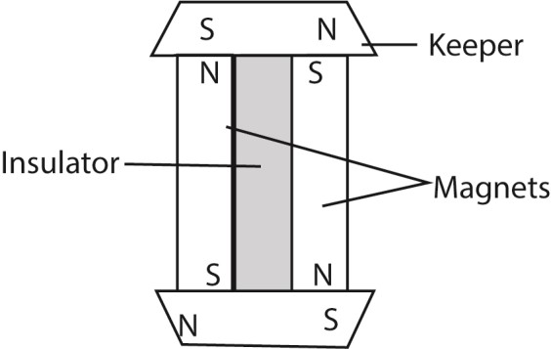

These iron keepers become induced magnets and their poles neutralize the poles of the magnets. This ensures that there is no magnetic loss.

Soft and hard magnetic substances
Soft magnetic materials are substance that are easily magnetized and easily lose magnetism, e.g. soft iron.
Soft magnetic materials are used in making soft-iron core in transformers, dynamos, e.t.c.

Hard magnetic material are materials that are difficult to magnetize but retain their magnetism for long, e.g. steel.
Hardmagnetic materials are used in loud spears.

Paramagnetism
Paramagnetism is a form of magnetism where a material is weakly attracted to an external magnetic field because it has atoms with unpaired electrons. These unpaired electrons align with the applied field, creating an internal magnetic field in the same direction, but the material loses this magnetism once the external field is removed.
Characteristics of paramagnetism
- Attraction to magnetic fields: : Paramagnetic materials are weakly attracted to an external magnetic field.
- Presence of unpaired electrons:
The property originates from the presence of unpaired electrons in the atoms or molecules of the material. These electrons have a net magnetic dipole moment.
- Temporary magnetism: When the external magnetic field is removed, the material loses its magnetism because the electron spins return to a random orientation.
- Weak effect: Compared to ferromagnetic materials, the effect of paramagnetism is relatively weak.
- Temperature dependence: The strength of paramagnetism is dependent on the temperature of the material.
Examples of paramagnetic materials
Liquid oxygen (O₂), Aluminum, Magnesium, Lithium, Tantalum, and Molybdenum

Diamagnetism
Diamagnetism is a fundamental property where materials weakly repel magnetic fields by creating an opposing magnetic field, a result of electron orbital currents opposing external fields, making them move from stronger to weaker field areas. It's present in all substances, but usually overshadowed by stronger magnetic effects, though it's strong in superconductors (Meissner effect) and observable in elements like gold, copper, bismuth, water, and even humans in strong fields (magnetic levitation).
Key Characteristics:
- Repulsion: Diamagnetic materials are repelled by magnets, unlike ferromagnetic or paramagnetic materials which are attracted.
- Induced Magnetism: An external field induces a temporary magnetic moment in the opposite direction, according to Lenz's Law.
- Weak Effect: Generally very weak and requires sensitive instruments, except in superconductors.
- Universal Property: All materials exhibit diamagnetism; it's just often masked.
- Negative Susceptibility: They have a negative magnetic susceptibility (χ < 0).
Examples:
Water, copper, gold, silver, bismuth, mercury, wood, plastics, and even air.

TOPIC 3/5: MAGNETIC EFFECT OF AN ELECTRIC CURRENT
Competency: The learner appreciates that a current carrying conductor in a magnetic field experiences a force and uses this concept to design models of different devices to solve societal needs.

Magnetic flux density, B
Magnetic flux density (B) is defined as the force acting per unit current per unit length on a wire placed at right angle to the magnetic field.

The S.I unit of B is tesla (T)
A tesla is the magnetic flux density in which a straight conductor of length 1m placed across the field and carrying a current of one ampere experiences a magnetic force of one Newton (1N)
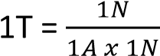

Magnetic flux, φ,
Magnetic flux, φ, is a measure of the number of magnetic lines passing normally across a given area of space. The strength of the magnetic field around a magnet depends on the number of lines per unit area.
Magnetic flux is thus, a product of magnitude of magnetic flux density and area of projection normal to magnetic field lines
I.e. φ = B x A = BA
S.I unit of magnetic flux φ is Weber (Wb)
If a magnetic field is at an angle, θ, to the area, A, then φ = BAcosθ

The Magnetic Force on a current carrying conductor placed across a magnetic field and Fleming's Left Hand Rule
A conductor carrying a current I placed in a magnetic field due to some source other than itself, experiences a mechanical force.

Demonstration of a magnetic force on a current carrying conductor
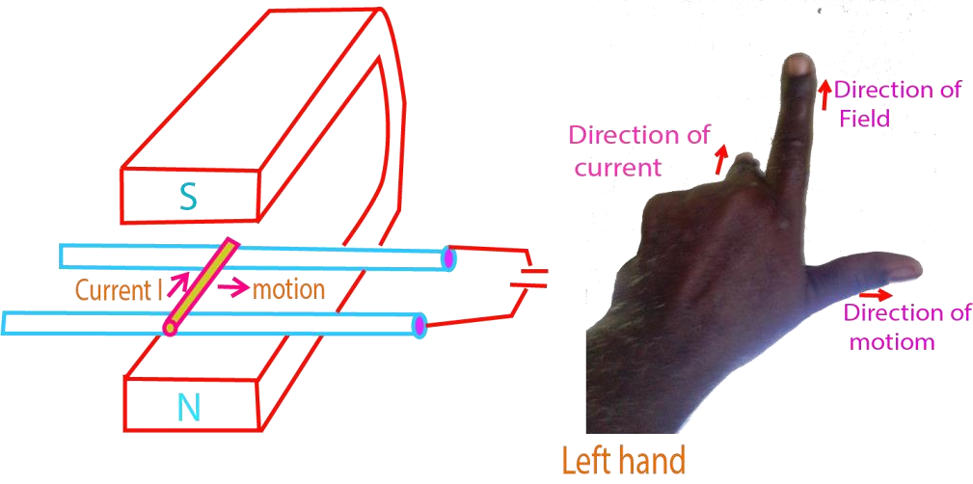
R
A short brass rod R is connected across a pair of brass rails, as shown in above.
A horseshoe magnet is placed so that the rod lies in the field between its poles.
When current passes through the rod, from an accumulator, the rod rolls along the rails, the direction of rolling is predicted by Fleming’s Left Hand rule.

Fleming’s Left Hand rule
States that when a straight conductor is placed across a magnetic field and a current is passed through it, the direction of magnetic force is predicted by the thumb when the first two fingers are placed perpendicular to each other. The first finger pointing in magnetic field direction and the second finger in the direction of current.
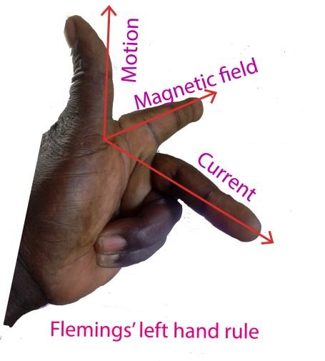

Explanation for the origin of the force of current carrying conductor in a magnetic field
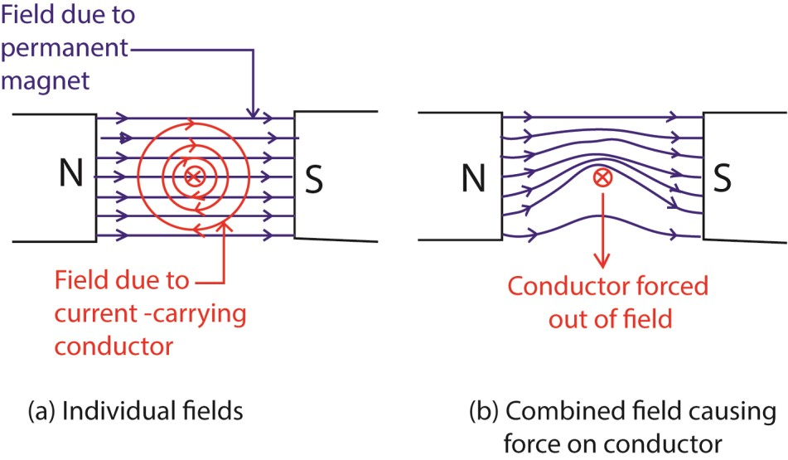
The current in the conductor produces a magnetic field around it.
This magnetic field of the current carrying conductor interacts with the magnetic field of the magnet.
This creates a region of stronger magnetic field on one side of the wire and a weaker magnetic field on the opposite side.
A net force F = BIL then pushes the wire/conductor from the direction of stronger field to that of weaker field as shown above.

Factors affecting the magnitude of force experienced by a current carrying conductor placed across a magnetic field
- Magnetic field strength or flux density, B; magnetic force increases with magnetic field density.
- Size of current, I, flowing through the conductor; the force is directly proportional to the current. iii. Length L of the conductor; the force is directly proportional to the length of the conductor. i.e. F L

iv. Angle of inclination of conductor across a magnetic field

θ

Current I

F = BILsinθ
When θ =90⁰; F = BIL
When θ = 0; F = 0
It follows that F is zero when the conductor is parallel to the field direction

Magnetic Permeability
Magnetic Permeability is the ability of the material to form an internal magnetic field within itself under the influence of an applied magnetic field.
Or
Magnetic permeability is the ability of a material to become magnetized when exposed to a magnetic field.
The SI unit of magnetic permeability is Henry per meter.
The main application of magnetic permeability is the characterization of magnetic materials such as paramagnetic, diamagnetic or ferromagnetic.
Electromagnets, transformers, and inductors use materials with significantly high magnetic permeability values.

Factors Affecting Magnetic Permeability
Magnetic permeability depends on the nature of the material, humidity, position in the medium, temperature, and frequency of the applied force.

Magnetic Permeability Formula
Magnetic permeability formula is given as;
Magnetic permeability (μ) = B/H
Where B = magnetic intensity and H = magnetizing field.
The SI unit of magnetic permeability is henneries per meter (H/m) or Newton per ampere squared (NA⁻²).

Types of Permeability
The different types of permeability include;
- Permeability of Free Space, air or vacuum.
It is represented by μ₀=B₀/H
The ratio of magnetic intensity in a vacuum and magnetizing field.
- Permeability of Medium
The ratio of magnetic intensity in the medium and magnetizing field.
It is expressed as; μ = B/H
- Relative Permeability
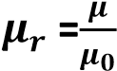
Relative permeability = (number of lines of magnetic induction per unit area in a material)/(number of lines per unit area in a vacuum)

Calculation of magnetic flux density due to a current in straight wire conductor, a solenoid and a plane circular coil
(a) The magnetic field density, B for a point at distance, d, perpendicular to a straight wire carrying a current I in a medium of permeability, μ is obtained as follows.

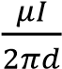

B =

B

B

d

d

I

In the vacuum B = 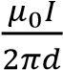 where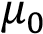 = 4π x 10⁻⁷Hm⁻¹

Example 1
Use the diagram below, write down the expression for magnetic flux density at P due to



30
0

X

B

A

P

Solution
The perpendicular distance, d, of P from AB = xsin30⁰.
Thus at P, B = 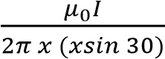

(b)(i) The magnetic flux density experienced at the centre and along the axis of a solenoid of length (L), number of turn (N), and carrying a current (I) is calculated from


Current into

Current out

Right

Left

L

C

C = center of the solenoid

At the center and along the axis of the solenoid magnetic flux density in air, B
B = 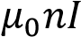 where n = (number of turns per meter)
Or
B = 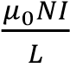
(b)(ii) The magnetic flux density experienced at either end of a solenoid of length (L), number of turn
(N), and carrying a current (I) in the vacuum is half that in the centre, C and is equal to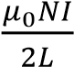

(c) The magnetic flux density B at the center of a plane circular coil of radius, r, and having N-turns of wire each carrying current I in the vacuum.



r
B

N
-
turns

Air/vacuum

Plane circular

coil

At the center of the coil, magnetic flux density, B = 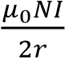 in the vacuum/air

Example 2
Determine the magnetic flux density at the center of plane circular coil of 10 turns each, radius r and currying a current I in a vacuum.

Solution
From B = 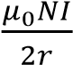
B = 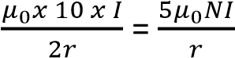

Example 3
A plane circular coil of 20 turns is placed with its surface flat on a horizontal table. If the plane of the coil is threaded by magnetic field of flux density 3.6x 10 ⁻⁵T at an angle 67⁰, find magnetic flux threading the coil of radius 5cm



67
0

B

B
sin67
0

Bcos67
0

Magnetic flux threading the plane of the coil normally φ = B’A where B’ = Bsin 67⁰
= BAsin 67⁰
= Bπr²sin67⁰
= 3.6 x 10⁻⁵ x π x (0.05)2 x sin67⁰
= 2.6 x 10⁻⁷Wb

Derivation of the formula, F = BIL
Consider a conductor of length L, cross section area A with N free electrons placed across magmetic Field of magnetic field density B.
When a p.d is applied across its ends, the electrons begin to drift with velocity, V=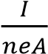; where n = 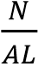 (number of electrons per unit volume.)
When the conductor is placed across an external magnetic field of density B, each electron experiences a force
F₁= BeV
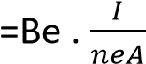
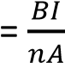
Total force on N electrons, F = NF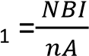
But N = nAL
Thus F = 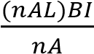 = BIL

Calculation of magnetic force due to parallel straight wires/conductors carrying currents
(a) Derivation of an expression of attractive force, F, between two parallel wires carrying currents I₁ and I₂ in the same direction
Let F₁ = B₂I₁L be the perpendicular attractive force wire 1 experiences due to magnetic field of wire 2 and F₂ = B₁I₂L be the perpendicular attractive force experienced by wire 2 due to magnetic field of wire 1


I
2

I
1

F
1

F
2

B
1

B
2

d

Wire 1

Wire 2

Magnetic field due to wire 1 a distance d away = 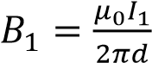
Magnetic field due to wire 2, a distance d away = 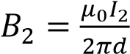
Magnetic force acting on wire 1, F₁ = B₂I₁L₁
Substituting for B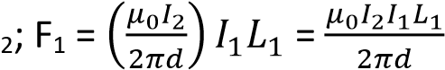 towards wire 2
Force per unit length, F = 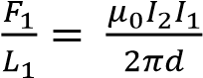
Magnetic force on wire 2, F₂ = B₁I₂L₂
Substituting for B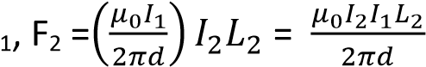 toward wire 1
Force per unit length F = 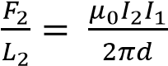
(b) Derivation of an expression of repulsive force, F, between two parallel wires carrying currents I₁ and I₂ in the opposite direction
Let F₁ = B₂I₁L be the perpendicular repulsive force wire 1 experiences due to magnetic field of wire 2 and F₂ = B₁I₂L be the perpendicular repulsive force experienced by wire 2 due to magnetic field of wire 1


I
2

I
1

F
1

F
2

B
1

B
2

d

Wire 1

Wire 2

Magnetic field due to wire 1 a distance d away = 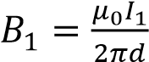
Magnetic field due to wire 2, a distance d away = 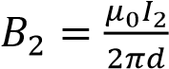
Magnetic force acting on wire 1, F₁ = B₂I₁L₁
Substituting for B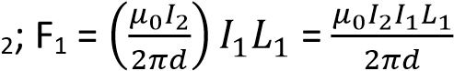 towards wire 2
Force per unit length, F = 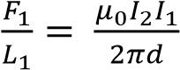
Magnetic force on wire 2, F₂ = B₁I₂L₂
Substituting for B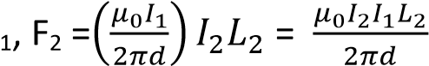 toward wire 1
Force per unit length F = 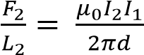
Generally F₁ = F₂ = F
When current is flowing in the same direction, the forces between the wires are attractive but in different directions, the forces are repulsive.

Ampere
It is a unit of current.

Definition
An ampere is a steady current which when flowing in each of two straight parallel wires of infinite length and negligible cross section area and placed a distance of 1m apart in a vacuum produce a force of 2 x107 N per meter on each other.
Derivation of an ampere
From expression 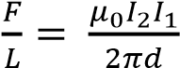
Suppose I₁ = I₂ = 1A, d = 1m, μ₀ = 4π x 10⁻⁷H/m
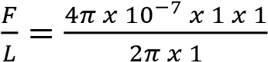= 2.0 x 10⁻⁷N/m

Example 4
Two straight wires A and B carry currents 4A and 6A respectively in a vacuum. Given that A and B are parallel to each other and are a distance of 2.0cm apart, calculate the resultant magnetic field mid-way between the wires carrying current in
(a) Opposite direction


Solution

cm
1

1
cm

B
A

B
B

A

B

B_{A} 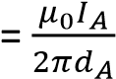; B_{B} 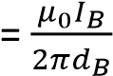
Resultant magnetic field midway, B = B_{A} + B_{B}; d_{A} = d_{B} = 1cm = 0.01m
B = T perpendicular to the plane of paper
(b) Same direction


1
cm

1
cm

B
A

B
B

A

B

Resultant magnetic field midway, B = B_{A} + (-B_{B}); d_{A} = d_{B} = 1cm = 0.01m
B = T perpendicular to the plane of paper

Example 5
Find the force per unit length of the wires when IA = 8.0A, I_{B} =11.0A and r = 3.0cm (04marks) The magnetic flux density which A produces at B is given by
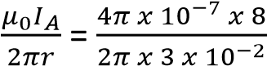= 5.30 x 10⁻⁵T
Force exerted by A on B, F = BI_{B}L
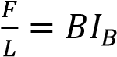= 5.30 x 10⁻⁵ x 11 = 5.85 x 10⁻⁴Nm⁻¹.
Or
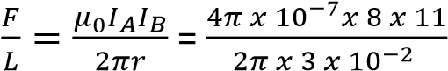= 5.85 x 10⁻⁴Nm⁻¹

Example 6
Two parallel wires P and Q, each of length 0.2m carry currents of 10A and 1A respectively
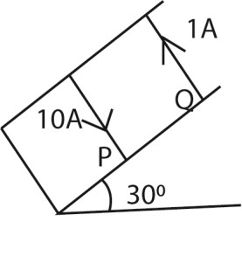
The distance between the wires is 0.04m. If both wires remain stationary and the angle of the plane with the horizontal is 30⁰. Calculate weight of Q.

Solution
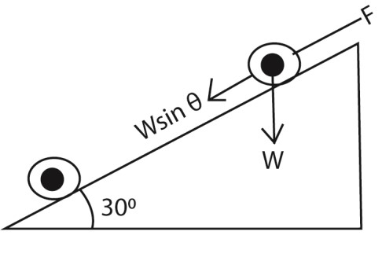
Force F between the two wires is given by
F = 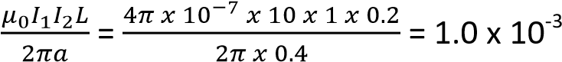N
But for equilibrium, the component of the weight along the slop is balanced by the magnetic force on the wire i.e. F = Wsinθ
=> W = 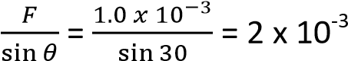N

Example 7
Two parallel wires, P and Q of equal length 0.1m, each carrying a current of 10A are a distance 0.05m apart with P directly above Q. If P remains stationary, find the weight of P. (03marks) Solution
Force due to magnetic field on P = weight of P, W.
W = 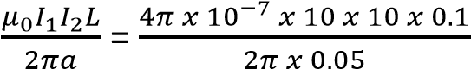 = 4.0 x 10⁻⁵N

Example 8
Two straight long and straight wires of negligible cross-section area carry currents of 6.0A and 3.0A in opposite direction as shown below
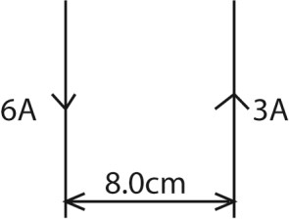
If the wire are separated by a distance of 8.0cm, find the;

- Magnetic flux density at a point mid-way between the wires (04marks)
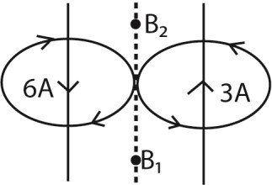
Magnetic flux density midway between the wires.
B = B₁ + B₂
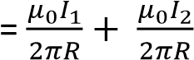
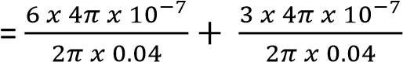
= 4.5 x 10⁻⁵T

- Force per meter between the wire (03marks)
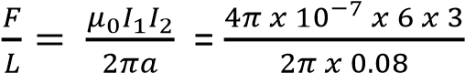= 4.5 x 10⁻⁵Nm⁻¹

Example 9
Two long parallel wires placed 12cm apart in air carry currents of 10A and 15A respectively in the same direction. Determine the position where the magnetic flux is zero. (04marks)
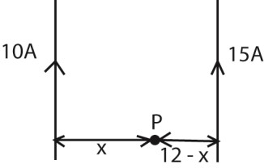
Let P be the point where the resultant magnetic flux is zero
Then, 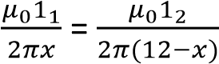
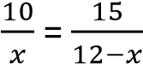
x = 4.8cm
P is 4.8cm from 10A current and 7.2 cm from the 15A current carrying conductor.

Measurements of current using a current balance
The ampere balance (also current balance or Kelvin balance) is an electromechanical apparatus used for the precise measurement of the SI unit of Electrical current, the ampere. It was invented by Williams Thomson 1St Baron Kelvin.
Set up
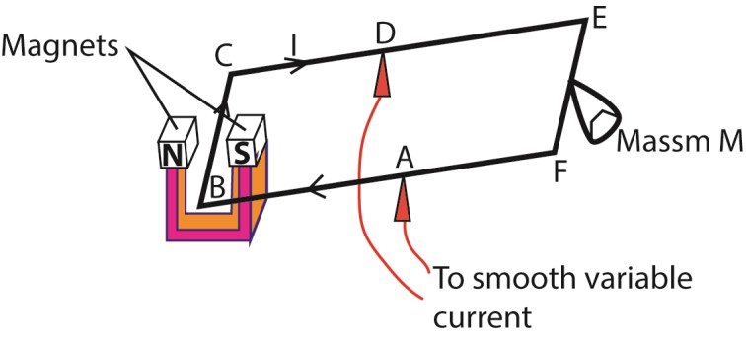
AB = AF, length BC = L and the current through the wire is A
The magnets provide a uniform magnetic field, B, perpendicular to wire BC.
At equilibrium when the frame BCEF is balanced
The force exerted on the wire = weight of the mass
BIL = Mg
I = 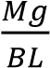

Sources of error
- Accuracy of length L
- Rigidity of the frame
- To avoid overheating, the current should be switched off as soon as measurements have been taken.
- Shield the set-up from the disturbance of wind.
Experiments to measure magnetic flux density

(a) An experiment to determine the magnetic flux density of a uniform magnetic field using a search coil and ballistic galvanometer
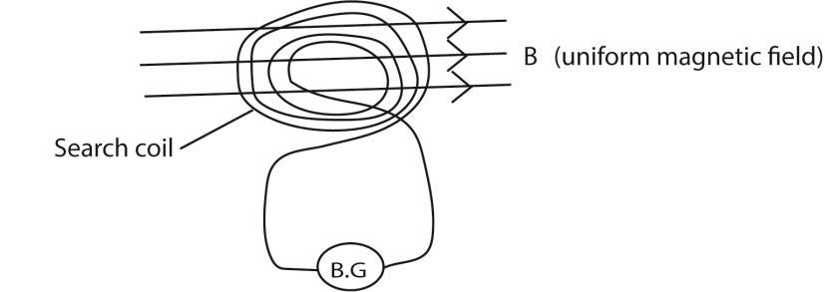
A search coil of cross section area A and number of turn’s N is connected in series with ballistic galvanometer. The search coil is then placed in uniform magnetic field such that the plane of the coil is perpendicular to the magnetic field. The coil is then pulled completely out of the field. The first deflection of the ballistic galvanometer noted θ₁.
- capacitor of known capacitance C is then charged to a p.d. V and then charged through the ballistic galvanometer, θ₂ is noted
The magnetic flux density of uniform magnetic field is obtained from
- = 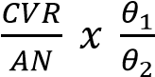
Where R is the resistance of the whole circuit.
(b) An experiment to measure the magnetic flux density between the poles of pieces of a strong magnet.
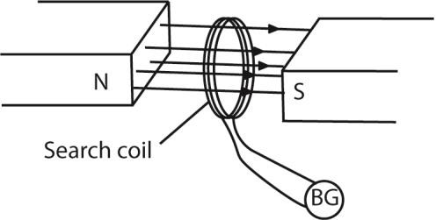
A search coil is connected to a ballistic galvanometer. The coil is then placed with its plane normal to the magnetic field whose magnetic flux density, B is required.
The coil is then pulled completely out of the field and deflection θ₁ of ballistic galvanometer is noted
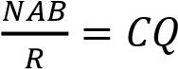, where R = resistance of the coil
A capacitor of known capacitance Q is charged to a p.d. V and is then discharged through the ballistic galvanometer. The deflection θ₂ is noted
CV = Cθ₂
The magnetic flux density B is now calculated from B = 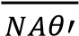 where A is the area of the coil, N is the number of turns in the coil and R is the resistance of the coil circuit.

(c) An experiment to determine the value of the earth’s magnetic flux density at a place, using a search coil.
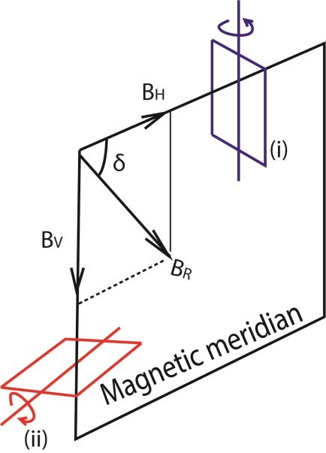
- A coil of known number of turns, N (about 100) and area A is connected to a calibrated ballistic galvanometer so that the total resistance in the circuit is R.
- The coil is placed in a vertical plane perpendicular to the magnetic meridian of the earth as shown in (i) in figure above. The coil is then rotated through 180⁰ about the vertical axis. The maximum throw θ₁ is noted.
- The coil is then placed with its plane in horizontal plane perpendicular to the magnetic meridian of the earth as shown in (ii) in figure above. The coil is then rotated through 180⁰ about the horizontal axis. The maximum throw θ₂ is noted. - Treatment of results
B_{H} and B_{V} 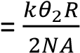
=

k is obtained by charging standard capacitor to a known p.d V and then discharging it through the ballistic galvanometer and the deflection α is noted. k = 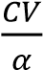
Then B is calculated from b = 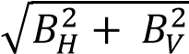

Magnetic moment
Magnetic moment, also known as magnetic dipole moment, is the measure of the object's tendency to align with a magnetic field.
Magnetic Moment is defined as magnetic strength and orientation of a magnet or other object that produces a magnetic field.
The magnetic moment is a vector quantity. Magnetic moments of two magnets are compared using a deflected magnetometer.

The structure and mode of action of the deflection magnetometer
It consists of a small compass needle (small magnet) enclosed in a transparent box which is pivoted on a vertical axis and carries alight aluminium pointer. The pointer can rotate over a circular scale.
The box is fixed in the center of wooden box with two arms of linear scales of 0.5m each that coincide at the center of the magnetic compass.
Deflection magnetometer is used for
- Comparing magnetic moments of two magnets - Verifying inverse law
The magnetometer can be used in two positions; i.e. Tan A position and Tan B position

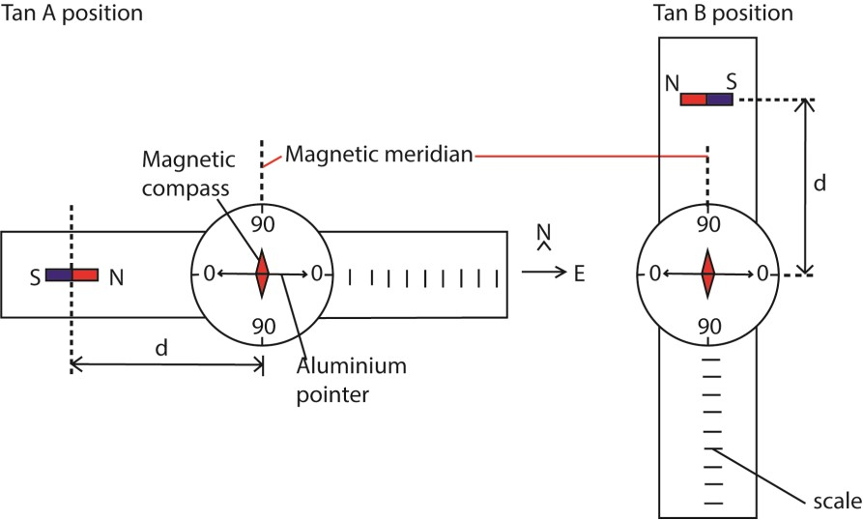 i. Tan A position
The arms of magnetometer are adjusted to be parallel the aluminium pointer so that they lie in east-west direction and compass pointer adjusted to read zero degrees on the circular scale while the magnetic needle lies in the direction of magnetic meridian
ii. Tan B position
The arms of magnetometer are adjusted to be parallel the aluminium pointer so that they lie in north-south direction and compass pointer adjusted to read zero degrees on the circular scale while the magnetic needle lies in the direction of magnetic meridian
(i) Comparing magnetic moments of two magnets using a magnetometer at equal distances in Tan A position
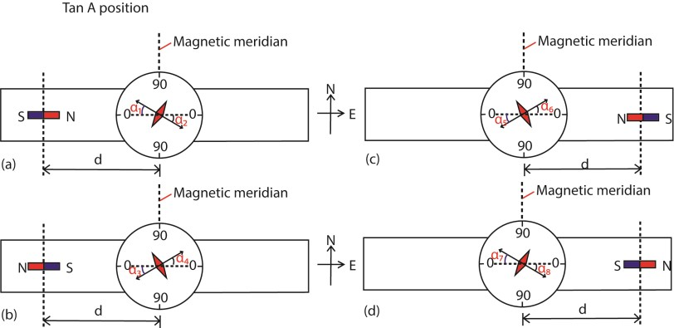
- The first bar magnet is placed a distance d from the magnetic compass as shown above and angles of deflection of aluminium pointer α₁ and α₂ are noted
- The polarity of the bar magnet in (a) is reversed and angles of deflections α₃ and α₄ are noted
- The first bar magnet is placed equal distance d from magnetic compass on the opposite arm and angles of deflection of aluminium pointer α₅ and α₆ are noted
- The polarity of the bar magnet in (c) is reversed and angles of deflections α₇ and α₈ are noted
- Average angle 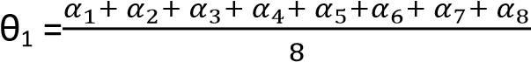
- Steps (a) to (e) are repeated for the second magnet to obtain average angle θ₂ (g) The ratio of magnetic moments is given by 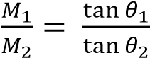
(ii) Comparing magnetic moments of two magnets using a magnetometer at equal distances in Tan B position
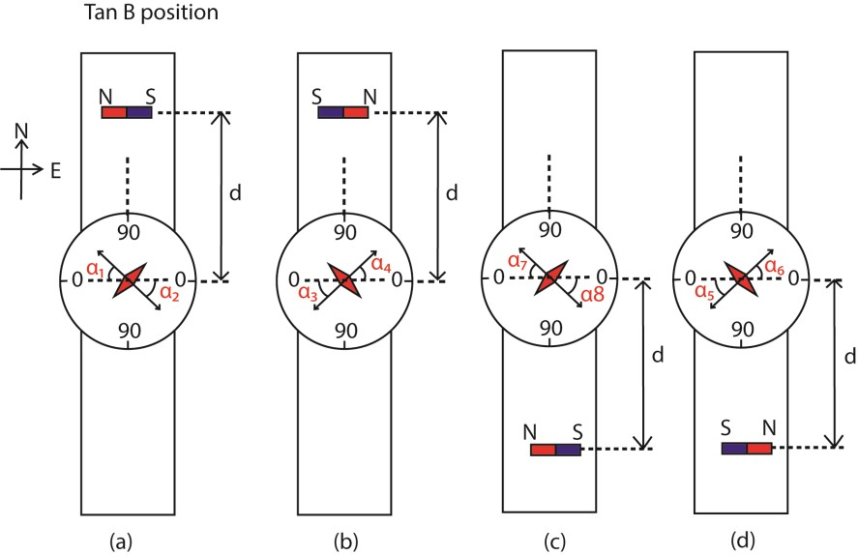
- The first bar magnet is placed a distance d from the magnetic compass as shown above and angles of deflection of aluminium pointer α₁ and α₂ are noted
- The polarity of the bar magnet in (a) is reversed and angles of deflections α₃ and α₄ are noted
- The first bar magnet is placed equal distance d from magnetic compass on the opposite arm and angles of deflection of aluminium pointer α₅ and α₆ are noted
- The polarity of the bar magnet in (c) is reversed and angles of deflections α₇ and α₈ are noted
- Average angle 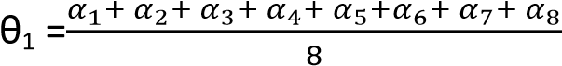
- Steps (a) to (e) are repeated for the second magnet to obtain average angle θ₂
- The ratio of magnetic moments is given by 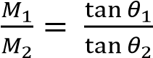

Comparing magnetic moments of two magnets using a magnetometer and null method in tan A position
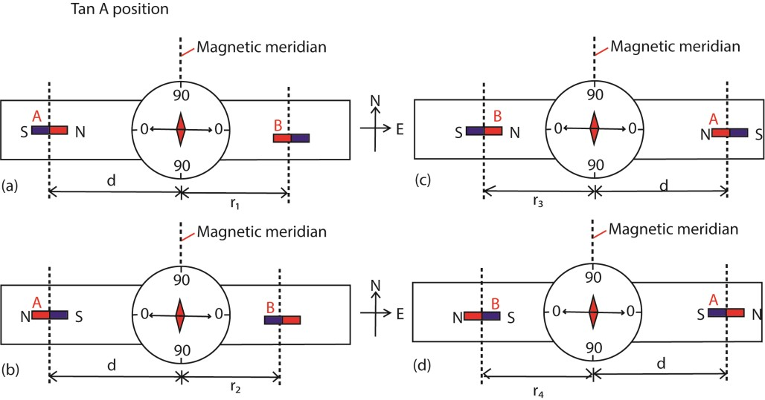
- Place one magnet a distance d₁ from the magnetic compass and another on the opposite arm facing each other.
- Adjust the second magnet to a distance r₁ until the compass needle shows zero deflection
- Reverse the poles of the two magnets keeping the distance d of the first magnet and determine the distance r₂ of the second magnet leading to zero to zero deflection.
- The magnets are interchanged keeping the distance d of first magnet unchanged, procedures (b) and C are repeated for distances r₃ and r₄.
- Now d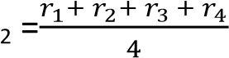
- The ratio of magnetic moments is given by 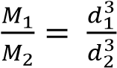

Comparing magnetic moments of two magnets using a magnetometer and null method in tan B position
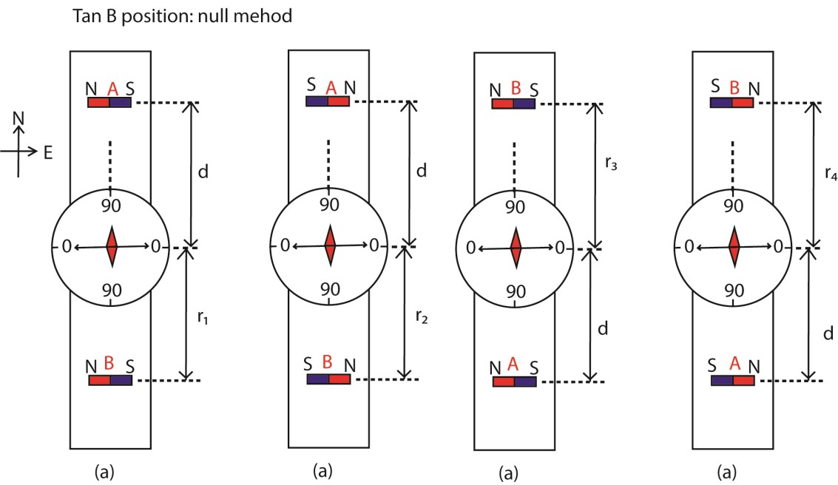
- Place one magnet a distance d₁ from the magnetic compass and another on the opposite arm facing each other.
- Adjust the second magnet to a distance r₁ until the compass needle shows zero deflection
- Reverse the poles of the two magnets keeping the distance d of the first magnet and determine the distance r₂ of the second magnet leading to zero to zero deflection.
- The magnets are interchanged keeping the distance d of first magnet unchanged, procedures (b) and C are repeated for distances r₃ and r₄.
- Now d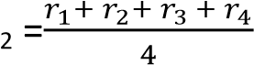
- The ratio of magnetic moments is given by 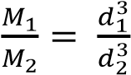
Verifying inverse square law
A. Arrange the magnetometer in tan A position
- The first bar magnet is placed a distance d from the magnetic compass as shown above and angles of deflection of aluminium pointer α₁ and α₂ are noted
- The polarity of the bar magnet in (a) is reversed and angles of deflections α₃ and α₄ are noted
- The first bar magnet is placed equal distance d from magnetic compass on the opposite arm and angles of deflection of aluminium pointer α₅ and α₆ are noted
- The polarity of the bar magnet in (c) is reversed and angles of deflections α₇ and α₈ are noted
- Average angle 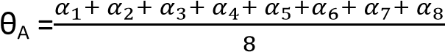
B. Arrange the deflection magnetometer in position B
- The first bar magnet is placed a distance d from the magnetic compass as shown above and angles of deflection of aluminium pointer α₁ and α₂ are noted
- The polarity of the bar magnet in (a) is reversed and angles of deflections α₃ and α₄ are noted
- The first bar magnet is placed equal distance d from magnetic compass on the opposite arm and angles of deflection of aluminium pointer α₅ and α₆ are noted
- The polarity of the bar magnet in (c) is reversed and angles of deflections α₇ and α₈ are noted
- Average angle 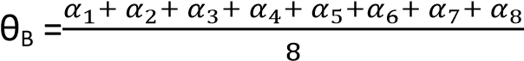
- Inverse square law is verified if 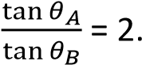

Magnetic moment of a coil
Magnetic moment is torque experienced by the coil per tesla of magnetic field acting along the plane of the coil.
Or
Magnetic moment of a coil is a couple exerted on a coil when it is placed with its plane parallel to a magnetic field of 1T

Derivation of expression for torque on rectangular coil in a magnetic field
Consider a rectangular coil of N turns each of dimensions a x b inclined at an angle α to uniform magnetic field of flux density, B.
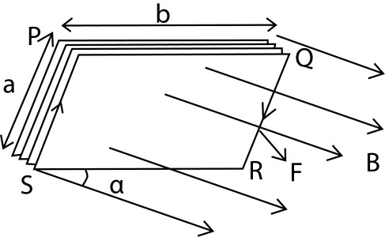
- When current, I, flows through the coil, the conductor experiences a magnetic force.
- Force on side PQ = NBIbsinα (downwards) while Force on side RS = NBIbsinsα (upwards). The two forces cancel out due to rigidity of the coil.
- Side PS experiences force NBIacosα perpendicularly into the page while RQ experiences force NBIacosα perpendicularly out of page. The two forces constitute a couple whose moment of force τ = F x b
= NBIabcosα
= NBIAcosα (where A is the area = a x b)

If θ is the angle between the field and the normal to the plane of the coil, then θ = 90° - α, and τ = NBIAsinθ

Example 14
A small circular coil of 20 turns of wire lies in a uniform magnetic field of flux density 5.0 x 10⁻²T. The normal to the coil makes an angle of 30⁰ with the direction of the magnetic field. If the radius of the coil is 4cm and the coil carries a current of 2.0A, find the

- Magnetic moment of the coil (02marks)
M = NIA = 20π x (4 x 10⁻²)² x 2 = 0.2Am²

- Torque on the coil
T = MBsinθ = 0.2 x 5 x 10⁻²sin30⁰ = 5.0x 10⁻³Nm

Example 15
Show that when the magnetic flux linking a coil changes, the total charge which passes through is depends only on the resistance of the coil and total flux linking it (05marks).
Consider a coil of N turns each linked by magnetic flux of φ₁.
Suppose the magnetic flux changes to φ₂.
When the magnetic flux φ changes, an e.m.f ε is induced in the coil.
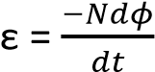
I =; R = the resistance of the coil ε = IR
Hence IR = 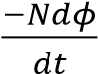
But I 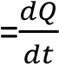; where Q is the induced charge
⇨ 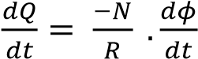
dQ = 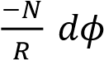
The amount of the charge which passes through the coil when the magnetic flux changes from φ₁ to φ₂ is
Q = 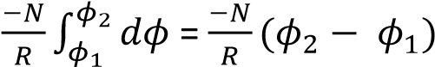

TOPIC 4/5: ELECTROMAGNETIC INDUCTION
Competency: The learner evaluates how magnetism and current are linked and how this principle is applied in the operation of transformers and generators.

Magnetic induction
This is the process by which a magnetic substance acquires magnetic properties temporarily due to the presence of a magnet close to it. For instance when a magnet is placed close to an iron piece without touching it, the iron piece behaves like a magnet.
Types of electromagnetic induction
Motional induction is the generation of an electromotive force (emf) in a conductor when it moves through a magnetic field.
Transformer induction involves the transfer of energy between two or more coils through changing magnetic field.

Self-induction
It is a process by which an e.m.f is induced in a coil or circuit when the magnetic flux linking it changes due to the current flowing in the same circuit/coil.
Experiment to demonstrate self-induction The circuit is arranged as shown below.
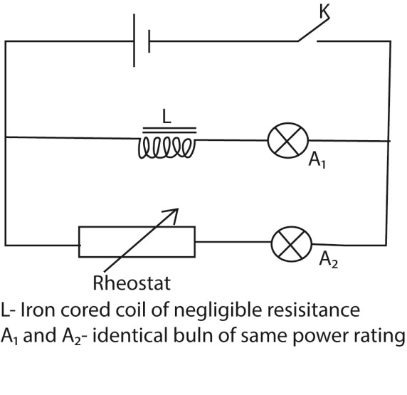

Procedure
- Switch K first closed and the rheostat adjusted until the two bulbs indicate the same brightness.
- When the switch is opened and closed again, bulb A₂ is observed to attain maximum brightness almost instantly while bulb A₁ take some time to attain maximum brightness.

Explanation
The current in A₁ takes some time to attain a steady value due to back e.m.f induced in the coil as a result of change in the current flowing (due to self-induction) in the coil when the switch is closed.
The back e.m.f gradually decay to zero as current establishes a steady value and hence the current in the coil rises slowly to its maximum when the back e.m.f is zero for there is no change in magnetic flux linking it.

Example 1
In the figure below, A and B are identical bulbs and L is an iron cored coil.
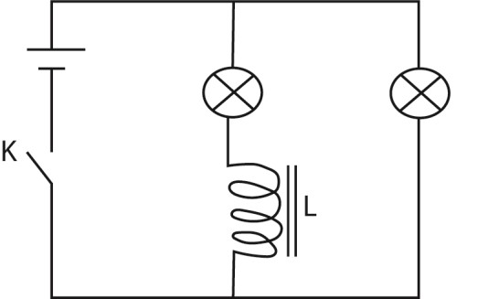
- Explain what will be observed when switch K is closed and then opened

When K is closed, bulb A light s dimly and slowly becomes brighter while B becomes bright almost instantly and later the two bulbs acquire the same brightness.

When K is closed, the current begins to flow around the closed circuit and gradually increases to its steady value or maximum. The sudden change or increase in the current creates an increase in the magnetic flux around the coil and large back e.m.f is induced into the coil due to selfinduction. This greatly oppose the flow of current in bulb A, causing most of the current to flow in bulb B, hence bulb A lights dimly and B brighter initially but latter the back e.m.f decay to zero and bulbs A and B now light to the same brightness.

When the switch is opened, bulbs A and B dim out gradually before going off. This is because opening switch will cause the currents and hence the magnetic flux around the coil to decay to zero. This cause back e.m.f in the opposite direction which tries to maintain the current in the circuit and hence the bulbs dim out gradually
- Explain what you would observe when a battery is replaced by a.c voltage source and K is closed.
Bulb A may not light while B lights brightly because a.c causes a higher constant rate of change in magnetic flux around the soft iron cored coil and hence back e.m.f is constantly induced in the coil which greatly opposes the flow of current in A. The current in A may not rise to a value enough to lit it.

Secondary observation
The iron core become warm
- The higher constant rate of change in magnetic flux induces eddy currents in the core which generate heat by I²R mechanism.
- The a.c causes the direction of the magnetic domain in iron core to change according to the changing flux. This requires energy (hysteresis) which is later converted into heat energy in the core

Mutual induction
It is a process by which an e.m.f is induced in a coil when the magnetic flux linking it changes as a result of a change in the current flowing in nearby coil.

Experiment to demonstrate mutual induction
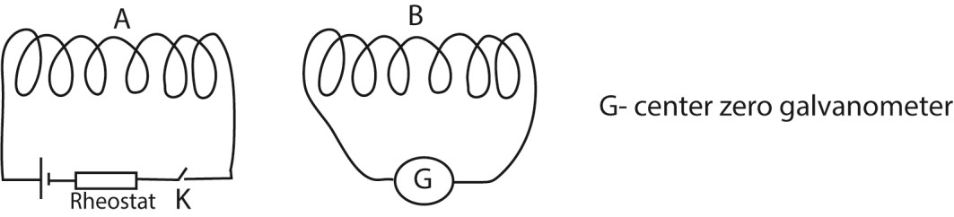
- The setup is shown above
- When the switch K is closed, the galvanometer deflects indicating induction of e.m.f in the coil B, hence mutual induction.

Self-inductance
This is the tendency of a coil to resist changes in current itself. Whenever current changes through a coil, they induce an emf, E which is proportional to the rate of change through the coil.
E = 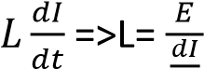
It can also be defined as the ratio of the magnitude of the back e.m.f induced in a coil or circuit to the rate of change of current flowing in the coil or circuit.
Or
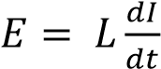
When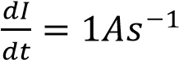;
E = L
Thus self-inductance can also be defined as the magnitude of the back e.m.f induced in a coil or circuit when rate of change of current flowing in the coil is 1As⁻¹.

Laws of electromagnetic induction
- Faraday’s law states that the magnitude of the e.m.f induced in a circuit is directly proportional to the rate of change of magnetic flux linked with the circuit.
- Lenz’s Laws states that induced current flows always in such a direction as to oppose the change which is giving rise to it.
An experiment to demonstrate Faraday’s law of electromagnetic induction.

Verification setup
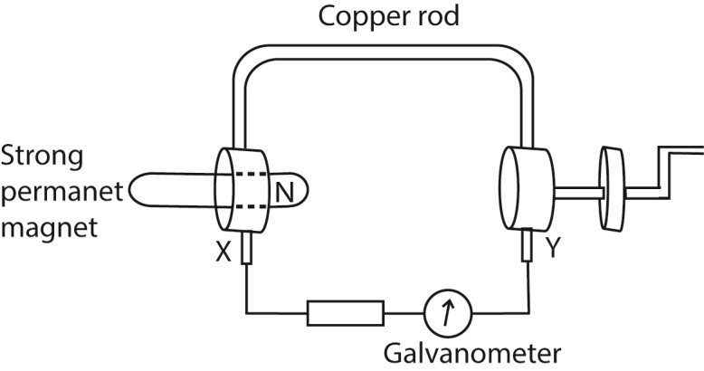
X and Y are brush contact.
A copper rod which can rotate round the north pole of permanent magnet is connected as shown above.
The wheel is turned steadily until the deflection of the galvanometer is constant.
The time, t, for N rotations is measured and the number of revolution (n) per second is determined from n = . The deflection θ of the galvanometer is also noted.
The experiment is repeated at different speed of rotation of the wheel and values of n and θ tabulated.
A graph of θ against n is plotted.
A straight line graph is obtained implying that θ n
Since θ e.m.f induced and n speed of rotation of the rod, then the induced e.m.f is proportional to the rate of change of flux linkage.

An experiment to illustrate Lenz’s law of electromagnetic induction

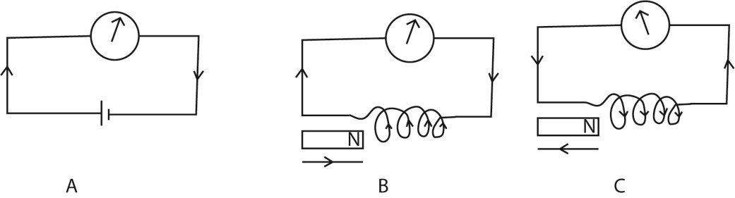
- The galvanometer is first connected in series with a battery and the direction for a given direction of current is determined.
- The battery is disconnected and is replaced by a coil of known winds.
- A strong permanent magnet is brought towards the coil with N-pole facing the coil, the galvanometer deflects in a direction for which the side of the coil facing the magnet is N-pole.
- When the magnet is move away from the coil, the galvanometer deflects in opposite direction, implying that the pole near the coil is an S-pole.
- In the first case, the pole due to the induced current was repelling the approaching magnet, while in the second case, the pole was attracting the receding magnet.
- The induced current therefore is in such as to oppose the change causing it, which is Lenz’s law.

Example 2
Explain why Lenz’s law is referred to as an example of energy conservation or
Why Lenz’s law does not violet the principle of conservation of energy.
In order not to violet the principle of conservation of energy, the effects of induced current must oppose the motion of the magnet in such a way that work done by an external agent in moving the magnet is the one that is converted into electrical energy and hence there is just transformation of energy from one form to another (from mechanical energy to electrical energy) and hence Lenz’s law is an example of energy conservation..
Magnitude of e.m.f induced in a coil depends on
- Number of turns N in the coil
- Rate of change in magnetic flux
- Strength of Magnetic flux
- Area of the coil

Derivation of e.m.f induced in a moving rod across a magnetic field

(a) Derivation of e.m.f induced in a moving rod by applying the laws of electromagnetic induction
Considering a rod of length L meters moving at right angles to a uniform magnetic field of flux density B tesla moving with uniform speed v ms⁻¹ as shown in figure below:
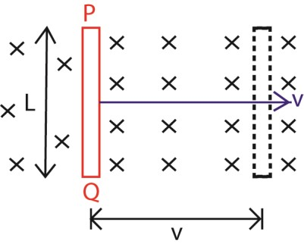
From the laws of electromagnetic induction;
The induced e.m.f, E = 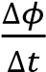
But φ = BA
E = 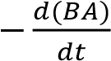
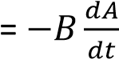
But 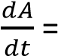-Lv
(negative because the area is decreasing, rate of decrease in area)
E = -B x –Lv
= BLv

Derivation of e.m.f induced in a moving rod by considering the force extended on the electrons
By virtue of motion of the rod in the magnetic field, the electrons inside the rod experiences a magnetic force.
Applying Fleming’s right Handle Rule, the induced e.m.f for current is directly from Q to P.
The electrons flow or drift from P to Q (by convention current and electrons flow in opposite directions) thus P acquires a positive charge and Q acquires a negative charge.
An electric field is thus setup which attracts electrons towards the positively charged end P.
Equilibrium is reached when upward electronic force is counterbalanced by the downward magnetic force.
At equilibrium, Ee =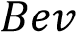
⇨ E = BV, where E is electric field intensity
But E = 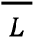 where E’ is the induced e.m.f.
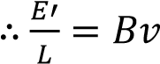
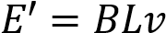 where = speed of the rod, B= magnetic flux density, L = length of the rod.

Derivation of e.m.f induced in a moving rod by applying the principle of conservation of energy
Consider a rod PQ placed at right angles to a uniform magnetic field of flux density B Tesla as shown.
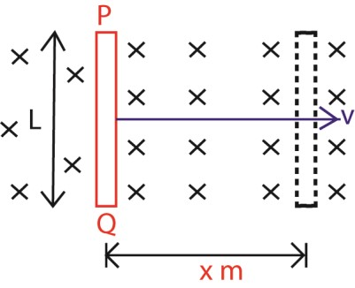
Suppose the rod is moved through of x meters in time t seconds; from the principle of conservation of energy, work done by the external agent in moving the rod is what is conserved into electrical energy.
Therefore, electrical energy = work done in moving the rod.
If E is the induced e.m.f in the rod, then
EIt = Force x distance
But force = BIL, I is the induced current in the rod
⇨ EIt = BILx
E =
Since 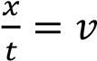(speed of the body) E = BL

Example 3
A rod PQ, 1.2m long moves at right angles to a magnetic field of flux density 0.4T and at a speed of 4ms1 . Find the e.m.f induced in the rod.
Solution
Induced e.m.f, E = BLv = 0.4 x 1.2 x 4 = 1.92V Example 4
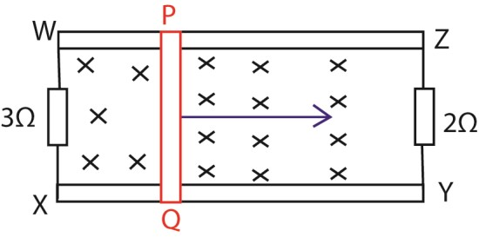
In the figure above, a rod PQ 1.2m long is moved in a perpendicular magnetic field of flux density 0.4T at a speed of 4m/s along a frictionless rails XY and WZ. Find the power generated by the rod.

Solution
Applying Fleming’s Right Hand rule, the induced current flows from Q to P, this gives the polarity of induced e.m.f with a positive terminal on the side P.
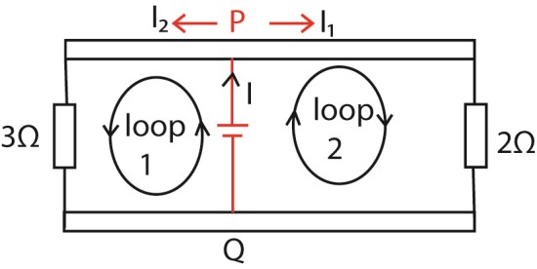
E = BLv = 0.4 x 1.2 x 4 = 1.92V
At the junction, I = I₁ + I₂
From I =
Considering loop 1;
I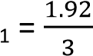 = 0.64A
Considering loop 1;
I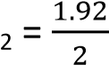 = 0.96A
I = I₁ + I₂ = 0.64 +0.96 = 1.6A
Power = EI = 1.92 x 1.6 = 3.1W

E.m.f induced in a circular disc (disc dynamo)
A disc is an arrangement of obtaining electrical energy from mechanical energy by rotating a circular metal disc in a perpendicular magnetic field abut an axle passing through its center.
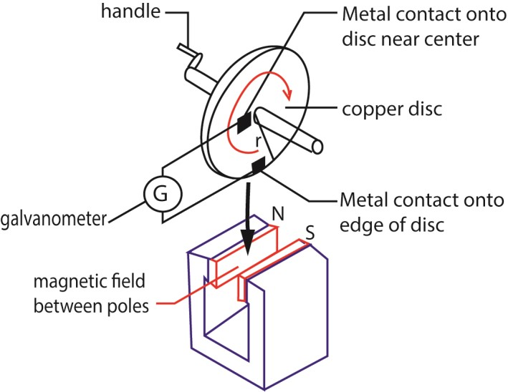
The disc is rotated at uniform angular velocity, ω, and the e.m.f induced in the disc is tapped by connecting a wire between the center of the disc axle and the rim of the disc.
The induced e.m.f is due to the motion of linear conductor of length = radius r.
From the e.m.f induced in a moving rod
E = BLv …………………………………….(i)
Where v is the average velocity,
v = 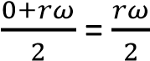 ……………………………. (ii)
(i) and (ii)

E =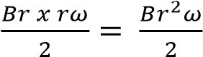
But ω =2πf, where f is the frequency of rotation per second
E = 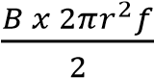 = Bπr²f
E = BAf

Example 5
A circular metal disc of radius 8cm is rotated at right angle to a uniform magnetic field of flux density 0.4T at 80 revolution per minute. Find the e.m.f induced in the disc.
Solution
Induced e.m.f, E = BAf, E = πr² = 3.14 x 0.08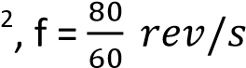
E = 0.4 x 3.14 x 0.08 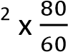= 0.011V

Example 6
A circular metal disc of radius 12cm is rotated in a perpendicular magnetic field of flux density 0.4T about an axle of radius 6cm at 52rev/min. Calculate the e.m.f generated
Solution
Induced e.m.f, E = BAf
= B (π(R² – r²)f
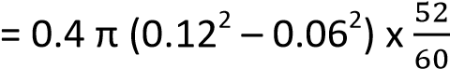
= 0.0117V

Example 7
A conducting disc of radius 0.05m with its plane perpendicular to uniform magnetic field of flux density 0.25T, rotates at 15 revolution per second about an axis through its center and perpendicular to its plane.
Calculate
- Magnetic flux threading the disc at any time (03marks)
Magnetic flux, φ = BA but A = πr²
- φ = Bπr²
= 0.25 x 3.14 x (0.05)² = 1.96 x 10⁻³Wb

- E.m.f generated between the center of the disc and any point on its rim.

or ε = φf = 1.96 x 10⁻³ x 15 =2.9 x 10⁻²V

Example 8
An airplane of wing span 30m flies horizontally at a speed of 1000kmh⁻¹.
What is the p.d across the tips of its wings, if the horizontal component of the earth’s magnetic field is 1.46 x 10⁻⁴T? (Angle of dip at the place is 70⁰) (03marks)
E = B_{V}Lv; but Bv = B_{H}tan70⁰
E = B_{H}tan70⁰Lv
= 1.46 x 10⁻⁴ x tan70⁰ x 30 x 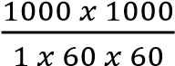 = 3.34V

Example 9
A circular metal disc of radius R. rotates in an anticlockwise direction at angular velocity, ω, in a uniform magnetic field of flux density, B, directed into paper as shown in the figure below
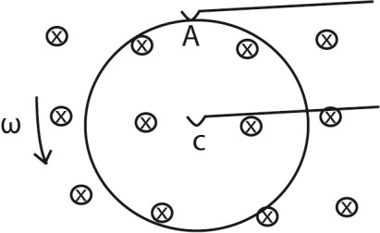
A and C are contact points
Derive an expression for e.m.f induced between A and C.

Le r = radius of the disc
Thus AC cuts the magnetic flux continuously.
The average velocity V of AC = 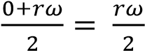
Induced e.m.f in Ac = E = BLV
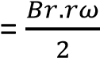
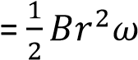

Absolute method of measurement of resistance (Lorentz method)
The e.m.f induced in a moving rod is used in the absolute measurement.
A circular metal disc is placed inside a solenoid X of known number of turns, N and length, L meters in series with a battery, unknown resistance R, a rheostat and a switch K
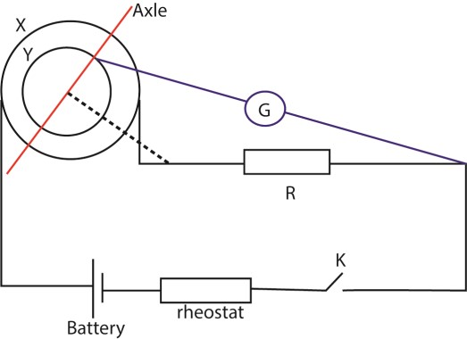
Switch K is closed and the disc of diameter, r, is rotated about an axle passing through its center at such a speed until the e.m.f induced between the center and the rim is counter balanced by the potential difference across the resistor when the galvanometer shows no deflection
At this stage, the number of revolutions n in a given time t (s) are noted.
f = revolution per second area A of the disc = 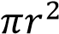
At no deflection the induced e.m.f in the disc, BAf = IR, where I is the current flowing through the coil
But B = 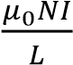
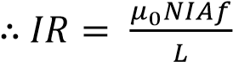
R = 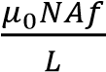

The simple a.c generator
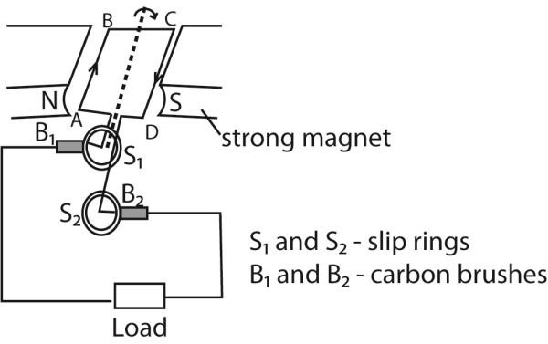
It consists of a rectangular coil of wire pivoted between opposite curved poles of a strong magnet and free to rotate about its axis with uniform angular velocity.

The ends of the coil are connected to two slip rings which press slightly against the carbon brushes connected to the load.

How it works
- The coil ABCD is rotated in a magnetic field, the magnetic field linked with it changes and hence e.m.f is led away by means of slip rings which press slightly against the carbon brushes.
- Applying Fleming’s right hand rule, the induced current enters the coil AB and leaves the coil via CD.
- Starting with the coil in the vertical position, the magnetic flux linking it is maximum and hence no induced e.m.f.
- The induced e.m.f increases with the position of the coil in the magnetic field until it becomes maximum with the coil in horizontal position and then decrease to zero as the coil rotates to the vertical position
- The force acting on the sides of the coil change as the coil passes over the position and hence he current flowing in the coil reverses. Hence an alternating e.m.f or current flows through the load.

A graph of induced e.m.f against time in an a.c generator
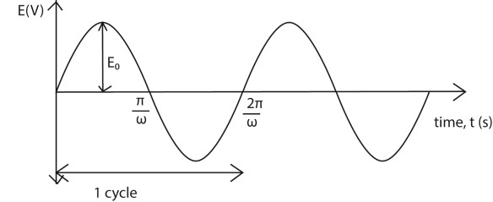
The main energy losses in an a.c. generator and how they are minimized
- Eddy current loss are minimized by laminating the armature
- I²R losses are minimized by use of low resistance winding wires - loss due to friction minimized by lubricating the rubbing parts

d.c. generator
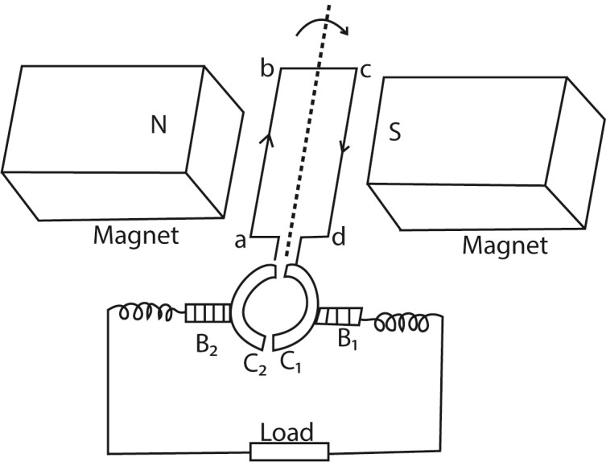
It consists of a rectangular coil abcd of wire pivoted between curved poles of a strong magnet and free to rotate about its axis with a uniform velocity.

The ends of the coil are connected to two halves of split ring (commutators) which press lightly against the carbon brushes connected to the load.

Mode of action
When the coil rotates at uniform velocity in magnetic field, e.m.f is induced in it. When the coil is in vertical position, the commutators change brushes C₁ to B₂ and C₂ to B₁.
E.m.f reverses direction but the current does not change direction. Hence current flows in the same direction in a resistor.

A graph of induced e.m.f against time in a d.c generator
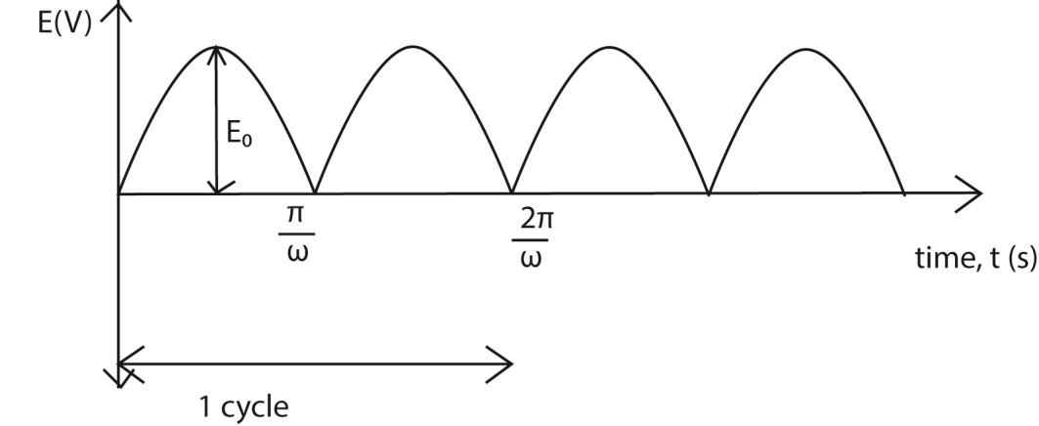
The peak value of induced e.m.f increases with increase in
- The number of turns in the coil
- The area of the coil
- The strength of the magnetic field
- The frequency of rotation of the coil
How to convert a d.c. generator be converted into an a.c. generator.
To convert a d.c. generator to an a.c. generator, the ends of the rectangular coil are connected to a pair of slip rings instead of the commutators.

How to convert an a.c. generator be converted into d.c. generator
To convert an a.c. generator to d.c. generator, the ends of the rectangular coil are connected to a pair of commutators instead of the slip rings.

A d.c motor
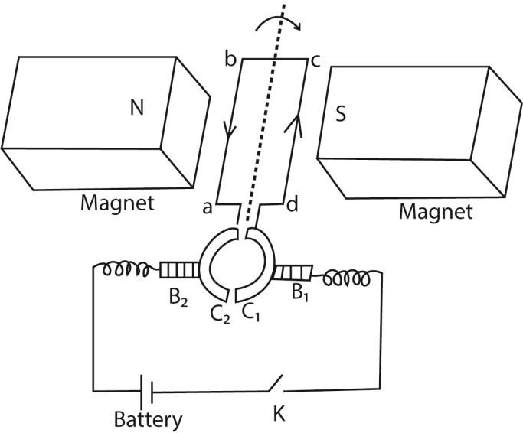
It consists of a rectangular coil abcd of wire pivoted between curved poles of a strong magnet and free to rotate about its axis with a uniform velocity.

The ends of the coil are connected to two halves of sprit ring (commutators) which press lightly against the carbon brushes.
Mode of operation
The switch K is closed and current flows in the coil in the direction shown
Applying Fleming’s left hand rule, ab experiences an upward force and side cd a downward force. the two forces constitute a couple which rotates the coil in a clockwise direction.
When the coil passes over the vertical position, the commutators change contact with the carbon brushes and current in the coil is immediately reversed. The forces acting on the sides thus change and the coil continues to rotate in the same direction.
Because the conductors cut the magnetic field, an e.m.f that oppose the supply voltage is induced in it called back e.m.f
If Vis the supply voltage and E is the back e.m.f, then then the current Ia is given by
Ia = 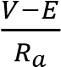 where Ra is the armature resistance

Back e.m.f and efficiency of the motor
When the armature coil of a motor rotates in magnetic field, an, e.m.f is induced in the coil. The induced e.m.f opposes the applied p.d. and is therefore a back e.m.f.

If V, E and r are applied p.d, induced e.m.f and resistance to the armature coil respectively, then the current flowing in the coil is given by
I = 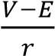
=> V- E = Ir
Multiplying through by I
VI = EI + I²r
Since I²r is the power dissipated as heat in the armature, EI is the mechanical power output and VI is the power supplied.
Efficiency of the motor, 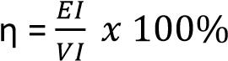
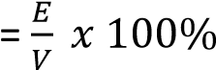

Example 10
A motor whose armature resistance is 2Ω is operated on 240V mains supply. If the back e.m.f in the motor is 220V, calculate the armature current. (03marks)
I = 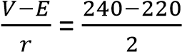 = 10A

Example 11
A transformer has 2000 turns in the primary coil. The primary coil is connected to a 240V mains. A 12 V,
36W lap is connected to the secondary coil. If the efficiency of the transformer is 90%, determine the
  - number of turns in the secondary coil (02marks)
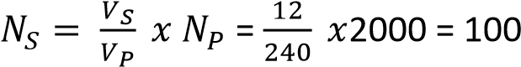
  - current flowing in the primary coil (03marks)
IsVs = 0.9IpVp
Ip = 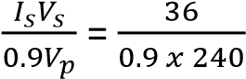 = 0.167A
Example 12
Explain the significance of back e.m.f. in the operation of a d.c. motor (02marks)

The back e.m.f in a d.c. motor provides the useful power of the motor.
The back e.m.f also reduces the heating effect in motor by reducing the current, since I = 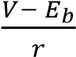 where Eb = back e.m.f

The structure and action of a.c transformer.
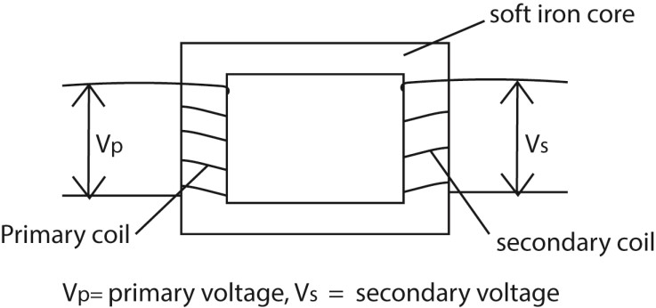
- Transformer consists of two coil of insulated wire, the primary and secondary wound on laminated soft iron core.
- When alternating voltage, V_{p} is connected to primary coil, it drives alternating current in the primary coil.
- The alternating current produces a varying magnetic flux _{φp} that link the primary coils inducing a back e.m.f E_{B} in the primary.
- The varying magnetic flux, φ_{s} links the secondary coil by mutual induction/inducing alternating voltage, V_{s} in the secondary
V_{p} 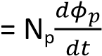 ……………………….. (i)
V_{s} 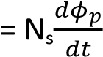………………………..(ii)
Eqn (i) Eqn (ii)
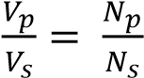
When N_{s} > N_{p} the transformer is a step up
N_{s} < N_{p} the transformer is a step down

Example 13
Explain why the voltage at a generating power station must be stepped up to very high value for long distance transmission (03marks)
Transmission is at high voltage to reduce power loss
Note that
Power supplied, P =IV
I =
Hence when V is high, I is small. From power loss, P’ = I²R, when I is small power loss is reduced.

Example 14
A transformer connected to a.c supply of peak voltage 240V is to supply a peak voltage of 9.0V to a mini-lighting system of resistance 5Ω. Calculate the
- r.m.s current supplied to the lighting system (02marks)
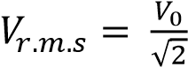
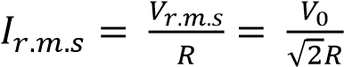
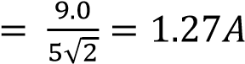
- average power delivered to the lighting system. (02marks)
P = I²R
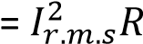
= (1.27)² x 5
= 8.1W
Example 15
Explain why the current in the primary coil of a transformer increases when the secondary is connected to the load.
When load is connected to the secondary winding, a current flows in it. The current flows in such a direction as to reduce the back e.m.f in primary coil, hence the current increase

Energy losses in a transformer
- Heat dissipated in the windings by I²R mechanism. This is minimized by use low resistance thick copper wires.
- Energy loss resulting from loss of flux or flux leakage. This is minimized by winding secondary coil on primary coil
- Eddy currents are minimized by laminating the core.

- loss due to friction minimized by lubricating the rubbing parts

- losses. When an alternating current is passes through the coil, wound on the core, the magnetic domain dipoles are forced to change directions according to changing magnetic flux created as a result of a.c. These changes of the domain dipoles require energy which is lost from the system. This energy loss is called hysteresis loss.

Hysteresis loss is minimized by using a core made of self-magnetic substance which requires very little energy to create magnetic reversal e.g. soft iron below the hysteresis curve of a ferromagnetic substance

A graph, explain the hysteresis curve for ferromagnetic material
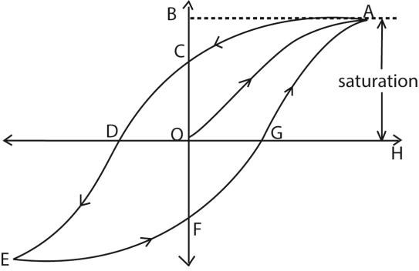
- When a magnetic field is applied to a ferromagnetic material, the magnetic domains tend to align with the applied field. The magnetic flux density increases along OA until saturation. When the magnetizing field is reduced to zero, there is residue magnetization at C. This is due to failure of the dipoles to respond instantly. Energy is lost.
- To bring the dipoles to their original orientation, a magnetic field OD is applied in opposite direction. As the magnetic field is increased in this reversed direction, saturation is attained at E
- When reversed magnetic field is reduced to zero, state F is attained. Reversal of dipoles requires an increase of magnetic field in opposite direction to state EF. The cycle is then repeated on further increase of magnetic field
- The curve of B verses H is called a hysteresis curve

Uses of transformers
A transformer is used to step up or down voltage to suit the required appliance.
The appliances that may require a transformer include telephone, radios, loud speakers, x-ray machines. T.Vs and so on.
Eddy currents
If a block of metal is moved in a magnetic filed or kept in changing magnetic field, free electrons in the conductor experience a force and begin to circulate.
This gives rise to induced currents in a closed circular path known as edd currents.
These currents flow in such a direction so as to oppose the motion of a conductor in the field.
Eddy currents produce a large amounts of heat in the soft iron core of transformers, induction coils,electronics and thus reduce efficiency of electrical devices.
Uses of eddy currents
- Damp oscillations in a moving coil galvanometer preventing oscillation of the pointer and leading to accurate reading
- Eddy currents produce enough heat to melt metals in induction furnace.
- Electric brakes: the axle of a train is surrounded by a coaxial cylindrical drum. When the train is to be stopped, a strong magnetic field is applied to the rotating drum. This generates large eddy currents that oppose motion of axle.
- Speedometer, eddy current are used in speedometer

TOPIC 5/5: A.C CIRCUITS
Competency: The learner measures a.c and investigates its behaviour in different devices.
Difference between a d.c generator and d.c motor
A d.c. generator converts mechanical energy into electrical energy while a d.c motor converts electrical energy into mechanical energy

Moving coil galvanometer.
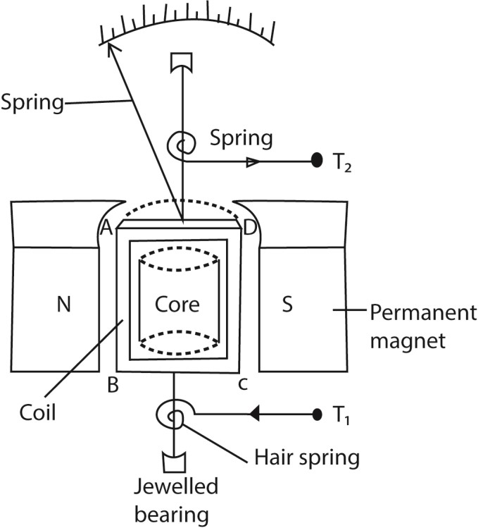
Structure
- It consist of a rectangular coil of fine insulated copper wire wound on an aluminium frame to provide electromagnetic damping.
- The coil together with the frame of aluminium are mounted over a soft iron cylindrical core and freely pivoted on jeweled bearing to minimize friction at contact.
- The suspension torsion wire suspending the coil is attached to a pair of control hair springs T₁ and T₂ for feeding current in and out of the coil and control rotation of the coil.
- The coil is then suspended between concave pieces of a strong magnet to provide magnetic field.

Mode of action
- Current I to be measured is passed into the coil via hair spring T₁.
- The current then causes the coil to experience a deflection torque, τ = NABI due to a couple force causing rotation in a radial magnetic field.
- The coil turns with the pointer through angle θ until stopped by a restoring torque, τ = kθ provided by a pair of hair springs T₁ and T₂.
- At equilibrium, NABI = Kθ
- current I = 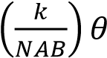
- I θ, hence the instrument has a linear scale
Where B = magnetic field strength between the poles of the magnets
A = area of the plane of the coil
N = number of turns of the coil
k = torsion constant of suspension spring

The factors which affect the current sensitivity of a moving coil galvanometer
- Strength of magnet, current sensitivity is proportional to the strength of the magnets
- Number of turns, current sensitivity is proportional to the number of turns
- Nature of suspension torsion wire, current sensitivity is inversely proportional to the torsion constant of the suspension torsion wire.
- Area A of the plane of the coil; current sensitivity is proportional to the area of the plane of the coil
- Size of copper wire making the coil; current sensitivity is proportional to the size of copper wires making the coil since the bigger the wires the lower the resistance.

Example 1
Explain why a moving coil ammeter cannot be used to measure alternating current from the mains.
(03marks)
The coil rotates about a vertical axis between the north and south concave poles of strong magnets. Thes provides a radial magnetic field. When an alternating current is passed through the coil, the torque on the coil reverses direction at the same frequency as current. The pointer vibrates with very small amplitude about the mean position hence a steady current reading cannot be taken

Example 2
Explain why a moving coil galvanometer should have a radial magnetic field, fine springs and many turns. (06marks)
Radial magnetic field ensures that the Force, F, remains normal to the plane of the coil when it turns through an angle i.e.
Torque on the coil τ = BANIsinα, where α is the angle between the normal to the coil and magnetic field this is balanced by restoring torque = kθ due to current, where θ is the angle turned through
Thus, current sensitivity given by 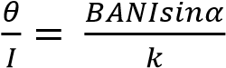
For a linear scale, sin α = 1 => radial field
For current sensitivity, k must be small; i.e. the springs must be fine For current sensitivity, N, must be large

a.c measuring instruments

(a) Thermocouple ammeter

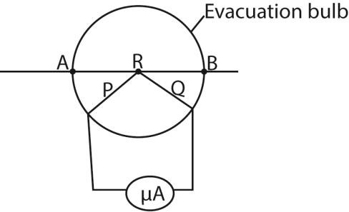
P and Q are dissimilar wires
Current to be measured is passed through the wire AB and heats the junction R of the thermocouple. The thermoelectric effect generated at R causes a direct current to flow through the micrometer calibrated to measure the r.m.s value of current.

Example 3
Explain any precautionary measure taken in the design of thermocouple meter (02mark)

The fine wire is enclosed in an evacuated glass bulb to shield it from draughts. If the wire was in the open, some heat would be lost to the surrounding so that the temperature difference between the hot and cold junctions would not be proportional to the power dissipated in the wire.

The repulsion type moving iron meter.
- 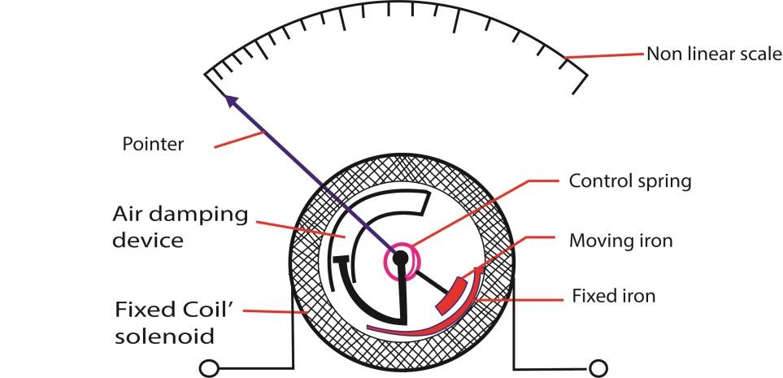
- When a current is passed through the coil, the iron rods magnetize in the same poles adjacent to each other in whatever the direction of current. Hence they repel and the pointer moves in the same direction until it is stopped by the restoring spring.
- Since the magnetic force is proportional to the square of the average current, hence, the deflection is proportional to the square of average current.
- Advantage: it measured both direct and alternating current.
- Disadvantage: it has nonlinear scale

A hot wire ammeter.
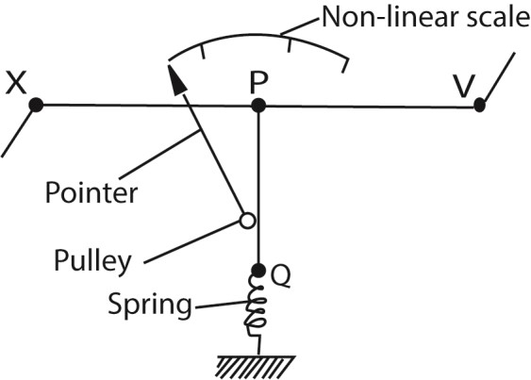
- The current flows through a fine resistance-wire XY, which it heats.
- The wire warms up to such a temperature that it loses heat-mainly by convection-at a rate equal to the average rate at which heat is developed in the wire.
- The rise in temperature of the wire makes it expand and sag; the sag is taken up by a second fine wire PQ, which is held taut by a spring.
- The wire PQ passes round a pulley attached to the pointer of the instrument, which rotates as the wire XY sags.
The deflection of the pointer is roughly proportional to the average rate at which heat is developed in the wire XY; it is therefore roughly proportional to the average value of the square of the alternating current, and the scale is a square-law one.

Sinusoidal a.c Currents
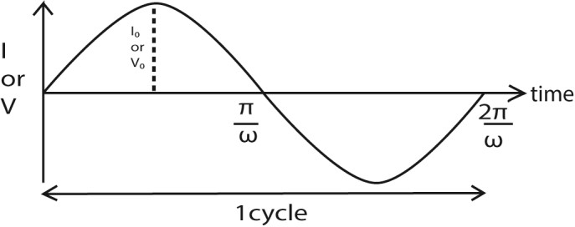
Terminologies
An alternating current or voltage
It is the voltage or current whose magnitude and direction varies periodically with time.
NB. Its variations with time can be represented by sine curve or wave and it is sometimes referred to as a sinusoidal current or voltage.

Example 4
What is meant by a sinusoidal voltage?
A sinusoidal voltage is a voltage whose variation with time can be represented by a sine curve.

Peak value/ amplitude
It is the maximum current or voltage of an alternating current.
NB: peak values are denoted by V₀, V_{m}, I₀. or I_{m}.

Root mean squared value (r.m.s)
It is a steady current or voltage that would dissipate heat in a given resistor at the same rate as the alternative current or voltage.
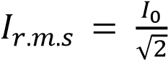 and 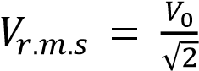
Period, T
It is the time taken to complete one cycle
Frequency, f
It is the number of cycles per second f =

a.c wave equation
The sinusoidal wave equation for a.c are represented by
V = V₀sin ωt and,
I = I₀sinωt
Where I₀ and V₀ are the peak alternating current or voltage
But ω = and T = ω =2πf
Thus the wave equations can be written as
V = V₀sin 2πf t and,
I = I₀sin2πf t
From Ohm’s law
V = IR
R = 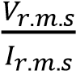

Example 5
Show that the r.ms value of an alternating voltage is V_{r.ms} 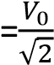, where V₀ is the peak voltage (03marks)
Instantaneous power =, where V = 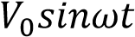
P_{inst} 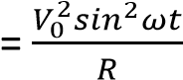
Average power, P = 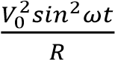
But sin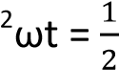
For steady voltage, P = 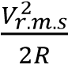
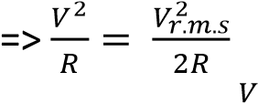
Hence V_{r.m.s} 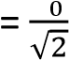

Example 6
A sinusoidal alternating voltage V = 170sin120πt, voltage, is applied across a resistor of resistance 100Ω
Determine
- The r.m.s value of current which flows. (03marks)
Ir.m.s = 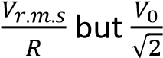
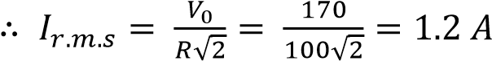

- The frequency of the current through the resistor. (02marks) ω = 2πf; ω = 120π
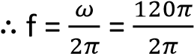= 60Hz

A capacitor in an a.c circuit
Consider a capacitor C farads in an a.c circuit as shown below
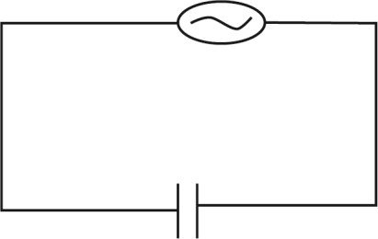
Assume a sinusoidal voltage
V = V₀sinωt ……………………….. (i)
Across the capacitor plates from definition of capacitor.
The instantaneous charge Q on plates is
Q = CV……………………………… (ii)
Putting (i) into (ii)
Q = C V₀sinωt ………………….. (iii)
From definition of current
I = 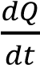(rate of charge flow)
I = 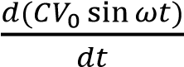………………….. (iv)
I = ωCV₀cos ωt ………………….. (v)
Putting ωCV₀ = I₀
I = I₀cosωt
From trigonometry, cos θ = sin (θ +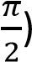
I = I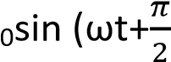)
= ωCV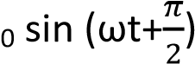
Hence the current leads the voltage by a phase angle of

Variation of V and I against time
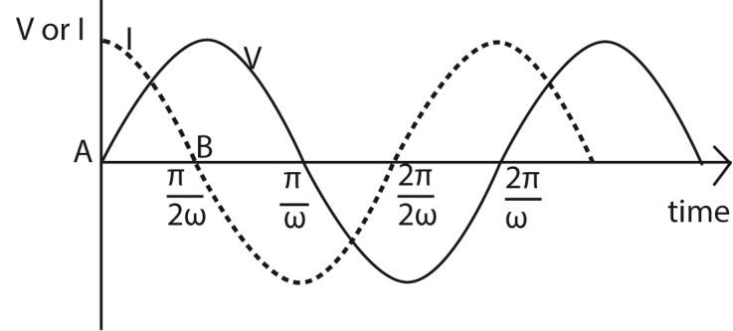
Explanation of the curve
- The current I through (not across) a capacitor is C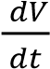. This is the slope of the voltage.
- When a capacitor is connected to an AC voltage (at the zero crossing) the maximum current flow will occur immediately, i.e. t = 0,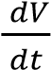 will approach infinity instantly and then repeat as a sinusoidal waveform.
- There will be a peak current at every zero crossing of the voltage waveform. The current waveform will lead the voltage waveform 90 degrees.

Reactance
This is the non-resistive opposition to the flow of alternating current in either a capacitor or an inductor.
Greater reactance leads to smaller currents for the same applied voltage. Reactance is similar to electric resistance, although it differs in several respects
Reactance of a capacitor (capacitive reactance) It’s denoted by Xc.
Definition, Xc = 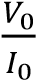 or Xc = 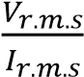

Derivation of an expression for reactance of a capacitor
Assume a sinusoidal voltage;
V = V₀sinωt ……………………… (i)
Across capacitor’s plates; the instantaneous charge Q is
Q =CV ……………………………… (ii)
Q= CV₀sinωt ………………….. (iii)
From definition of current,
I = 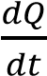(rate of charge flow) ……. (iv)
I = 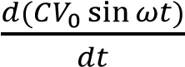 ……………………… (v)
I = ωCV₀ cos ωt ……………………. (vi)
But ωCV₀ = I₀ ………………………. (vii)
From definition
Capacitance reactance, Xc = 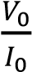
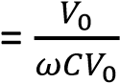
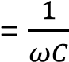
But ω = 2πf
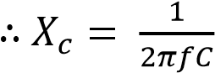

Example 7
A sinusoidal voltage of r.m.s value 13.2V is connected across a 50μF capacitor.
- Find peak value of the charge on the capacitor (02marks)
Hence

√

= 50 x 10⁻⁶ x 13.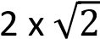
= 9.333 x 10⁻⁴C
- If the frequency of the alternating current is 49.6Hz, calculate the r.m.s value of current through the capacitor. (03marks)
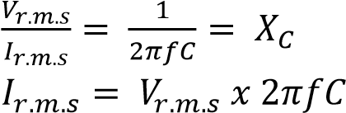
= 13.2 x 2π x 49.6 x 50 x 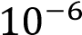 =0.206A

Example 8

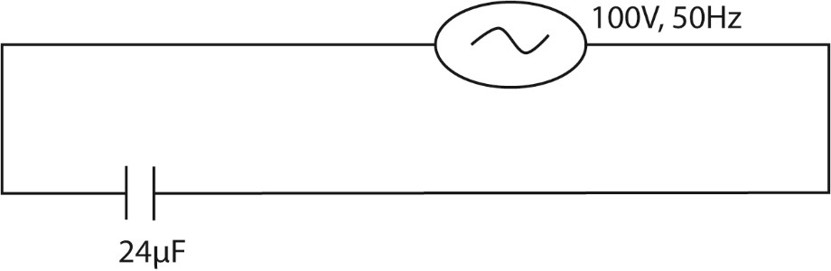
A 100V, 50Hz a.c. supply is connected across a capacitor of 24μF as shown in figure above. Calculate the reactance of the circuit (03marks)
Capacitive reactance, Xc = 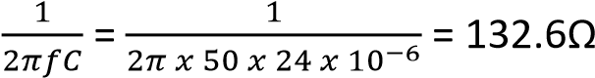

Example 9

A capacitor of capacitance 60μF is connected to an a.c. voltage supply of frequency 40Hz. An a.c ammeter connected in series with the capacitor reads 2.2A. Find the p.d across the capacitor.
(03marks).

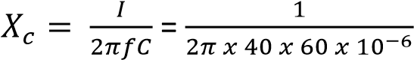
Voltage, V_{r.m.s} = I_{r.m.s} x Xc
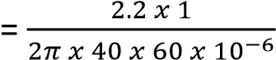
= 146V

Example 10
A sinusoidal p.d of r.m.s value of 20V and frequency50Hz is applied across a 100μF capacitor. Calculate the capacitive reactance of the circuit. (02 marks)
Xc = 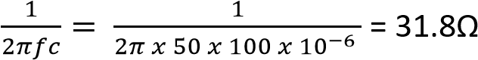

a.c through an inductor
An inductor, also called a coil, choke, or reactor, is a passive two-terminal electrical component that stores energy in a magnetic field when electric current flows through it. An inductor typically consists of an insulated wire wound into a coil
Example of inductors
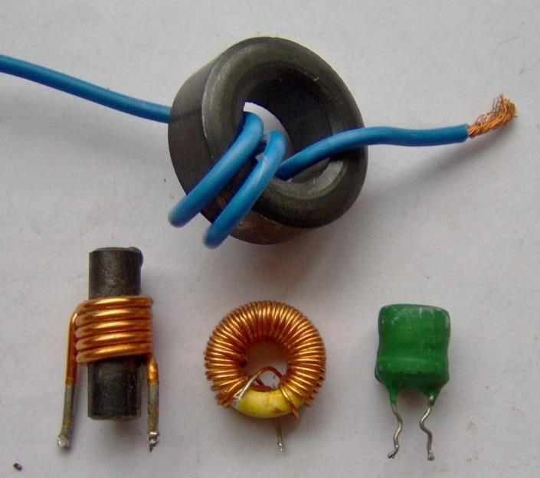

Example 11
- Show that in a coil placed in an a.c circuit, the voltage across the coil leads the current by a phase angle of 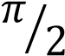 radian or 90⁰
Instantaneous voltage, V = V₀sin2πft,
E_{B} 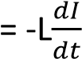
But for finite current, V = -E_{b}
V =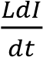; but V = V₀sin2πft,
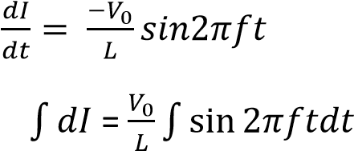
I= 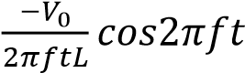
From trigonometry, cos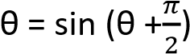
I= 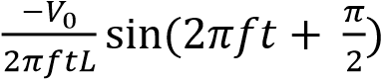

⇨ I lags V by or 90⁰

- Using the axes, sketch graphs to show the relative phases of the current and voltage across the inductor. (02marks)
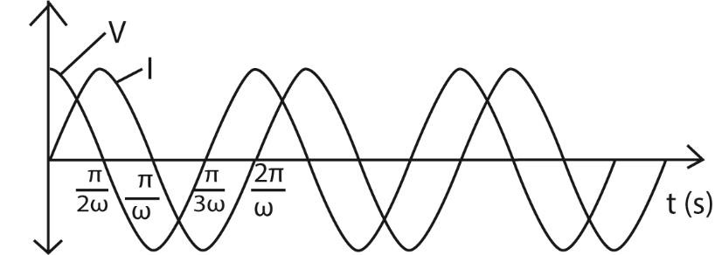

Note that the current starts at zero and rises to its peak after the voltage that drives it, i.e., the voltage across an inductor leads the current because the Lenz’s Law behavior resists the buildup of current and it takes a finite time for an imposed voltage to force the buildup of current to its maximum.

Derivation of an expression for reactance of an inductor
Method I
Induced e.m.f = -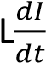
E= -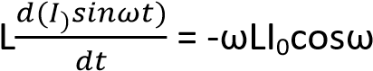t
Current flow in a pure inductors, V = -E = ωLI₀cosωt
Hence V = V₀cosωt where V₀ = ωLI₀
Inductance = X_{L} 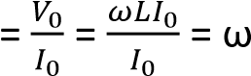L
Method II
V = V₀cosωt
Induced e.m.f E = -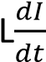
Since the inductor is a coil of zero resistance (for finite current) V = -E
V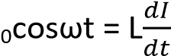
dI = 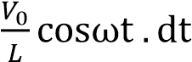
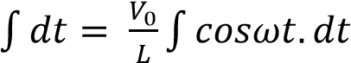
I =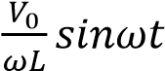
But 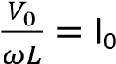

X_{L} 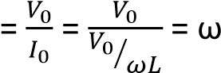L

Ballistic galvanometer
It is a moving coil galvanometer used for estimating the quantity of charge flow whose deflection of the coil is directly proportional to the charge that passes through it.

